AWS Part 1, Labs 1-3

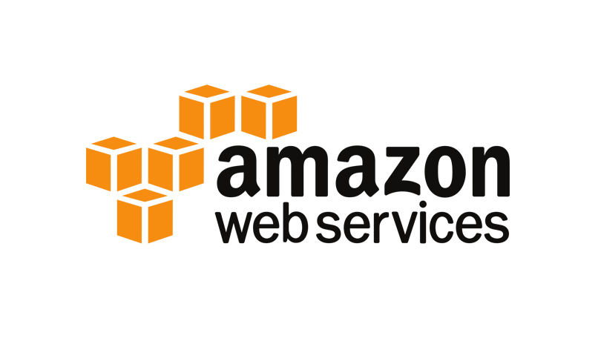

The purpose of this lab was to teach us how to use AWS. This shows us how to make virtual servers and other software. In CCNA, we were taught about virtualization and its benefits over traditional servers. However, we didn’t do many (if any) labs that involved virtual servers. Now with AWS, we could assume all our servers are running virtually and we did 6 labs to show the functions of AWS. This write-up will show the first three, while the other three labs will be shown in a different write-up.

First, some background. **A**mazon **W**eb **S**ervices is a service that provides virtual cloud computing for people who pay for the system. This system is a pay-as-you-go system, so if you are using more space, you pay more. This provides lots of advantages over having your own servers. You don’t have to make your own server room and you only pay for what you need. However, there are drawbacks, such as switching cloud service providers or occasional downtime.

One notable advantage of AWS is that you don’t need to have a massive server room. Because all the data is stored in a cloud, you don’t need to hold all of it in a server room. Thanks to this, you don’t need to spend a ton of money to expand the server room if you run out of space, nor do you have to worry about spending money on a bunch of servers that you will never use. Cloud computing also is more secure. You don’t have to worry about having someone break into the room and gather sensitive information, so you can also spend less money on security for resistant locks and security cameras. Best of all, you also don’t need to spend any money on maintenance for your server room or anything. AWS handles all that for you.

Cloud computing services like AWS follow a pay-as-you-go system. This means that if you use more data, you pay more money. This is a dynamic payment system that works great for businesses. They end up just paying for however much data is being used, which is predictable. All you have to do to determine the cost of your service is to go to this website (<https://calculator.aws/#/>), tell it what services you want to use and how much data is expected to be consumed while your virtual servers are running, and it will automatically calculate the cost of the type of data and how much you are expected to pay per month.

However, cloud computing services like AWS have their drawbacks. One problem is that cloud services may have downtime. This is a problem when businesses are trying to get their data, but the cloud service is down. If the business can’t get its data from AWS, especially in critical situations, the business may have to be suspended for a while until the servers are back up. They may not be able to get the change out in time and could lose money. Also, switching from one cloud service to another can be a nightmare. If someone wanted to switch from AWS to something like Microsoft Azure, migrating all the data and setting up everything again can be a huge pain. This could result in using both services charging them until all their data is eventually moved.

In summary, I learned about AWS’s power and usefulness, then about certain parts and their functions. I then completed 3 labs, each showing an individual piece of AWS.

Here are the "commands” that I used to complete this lab. These will all be pictures of the instructions because the labs were just following the instructions. This is also like the diagram. Normally, I would use a premade drawing of the labs. However, I can’t exactly show the AWS servers, so the instructions will be close enough.

Lab 1

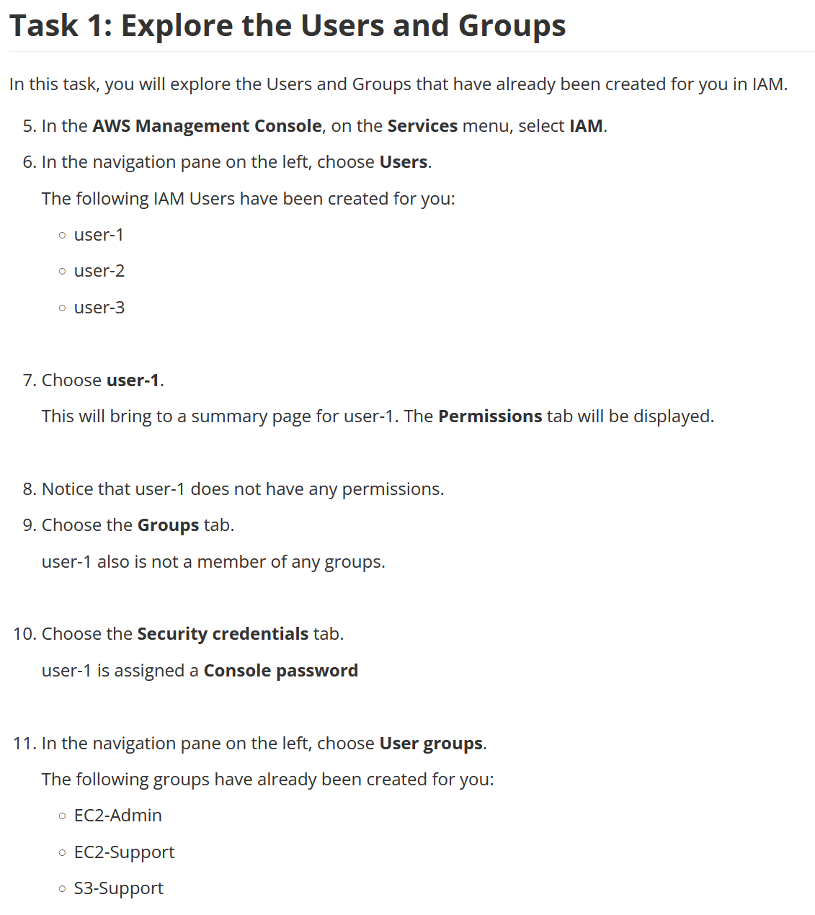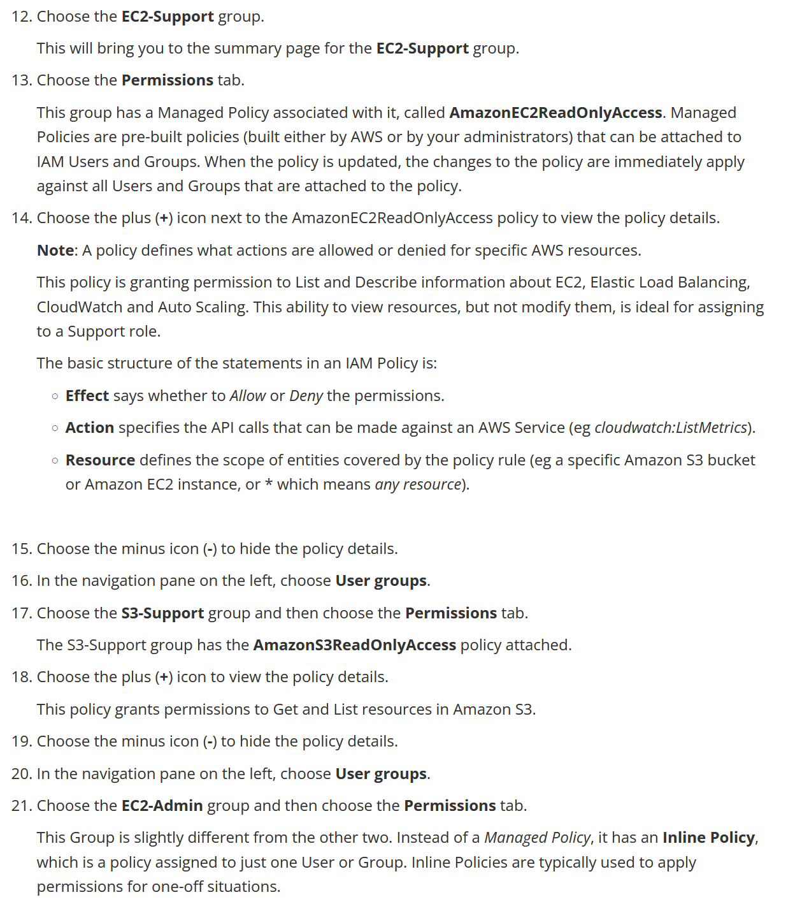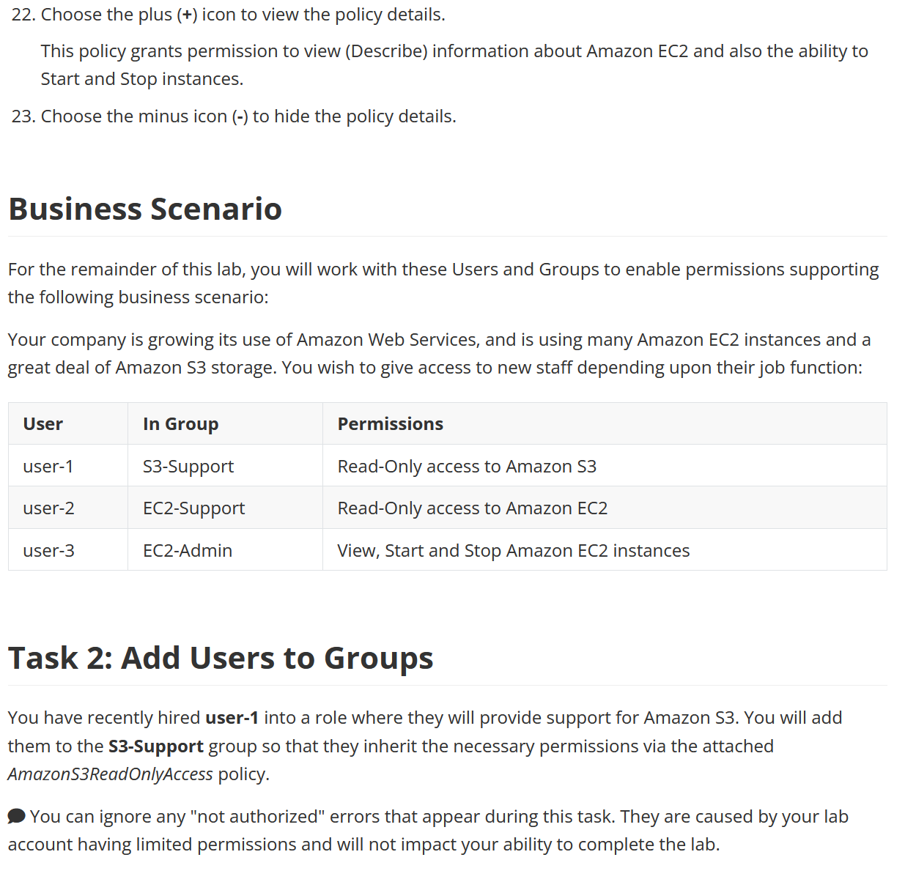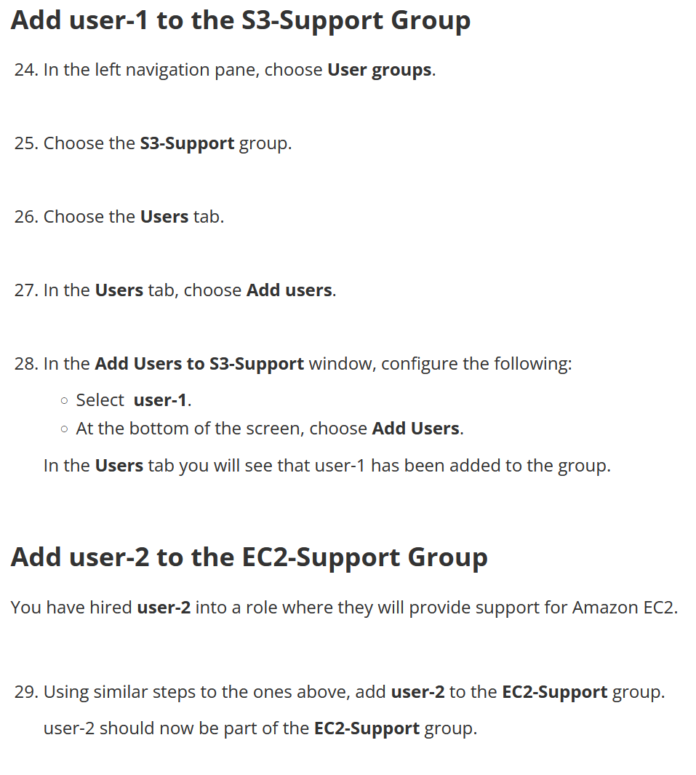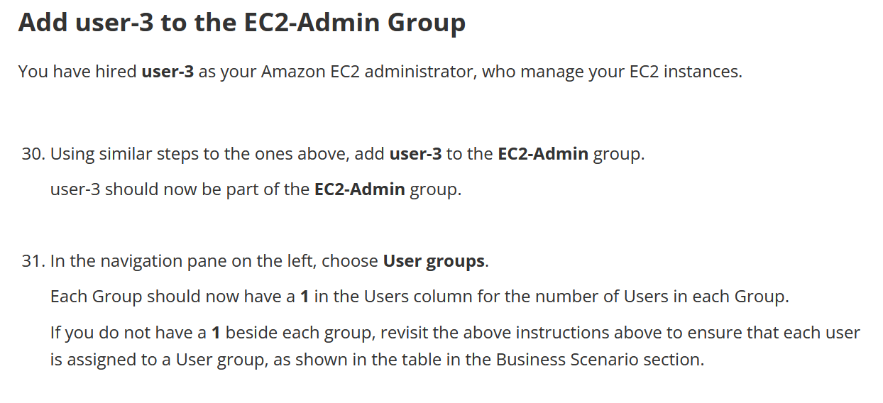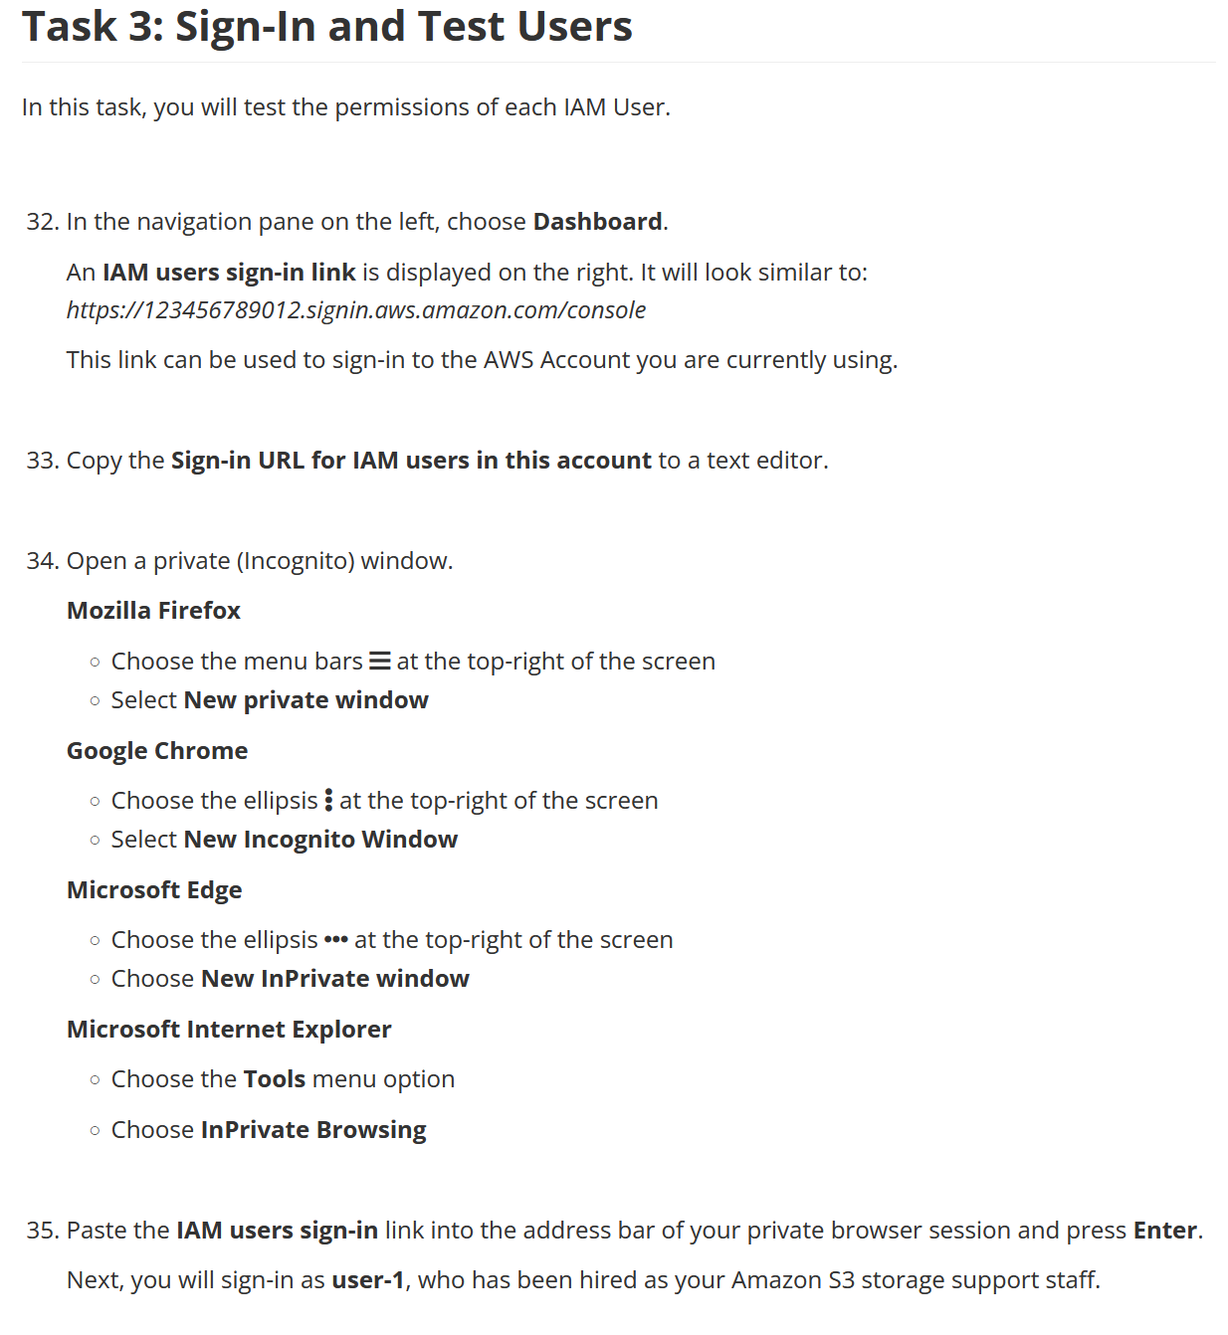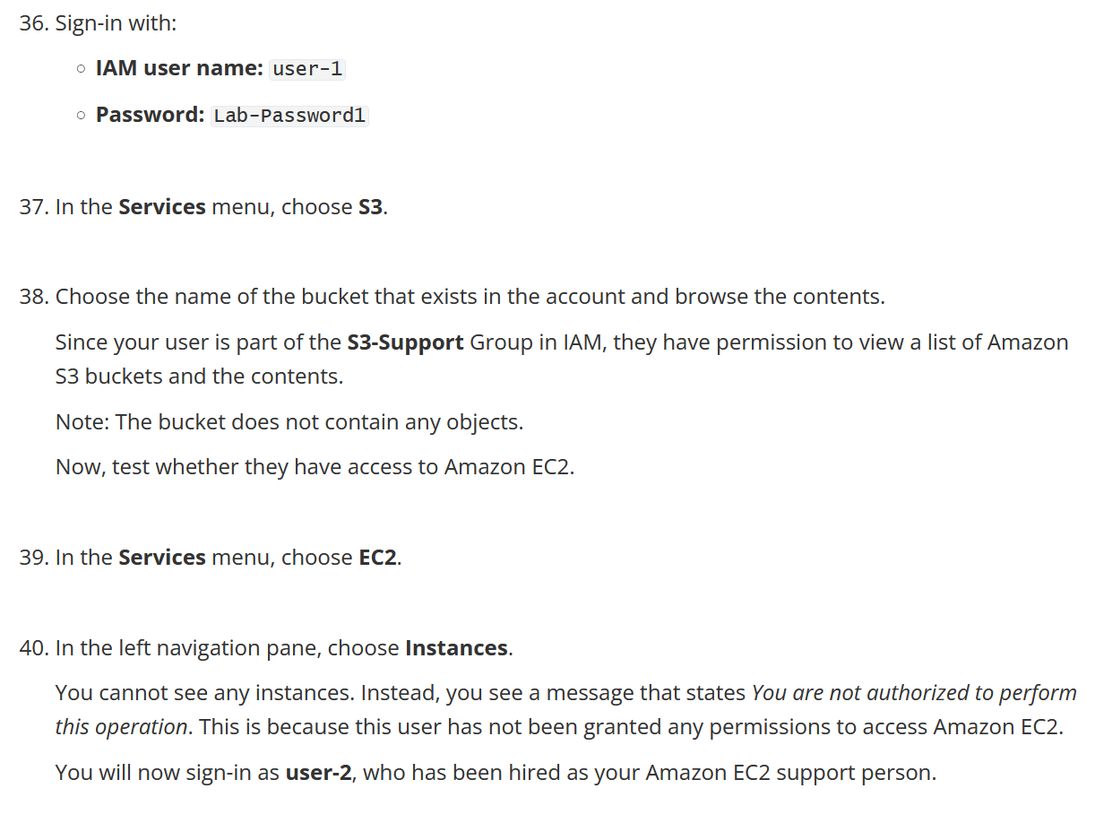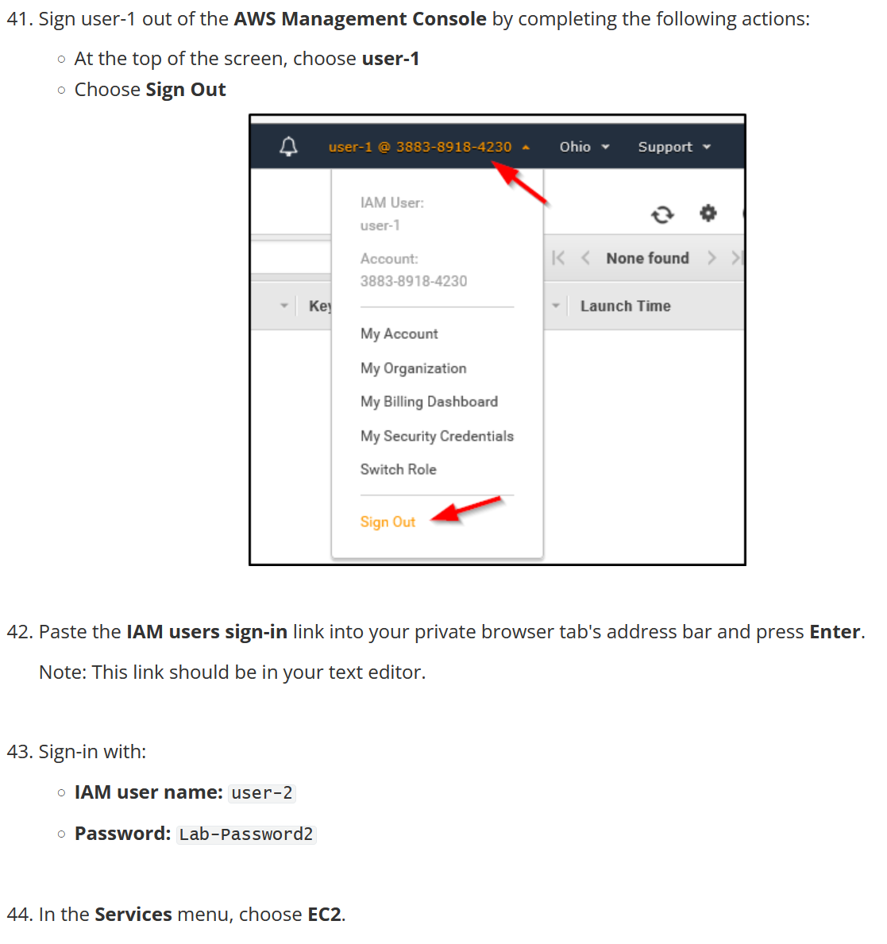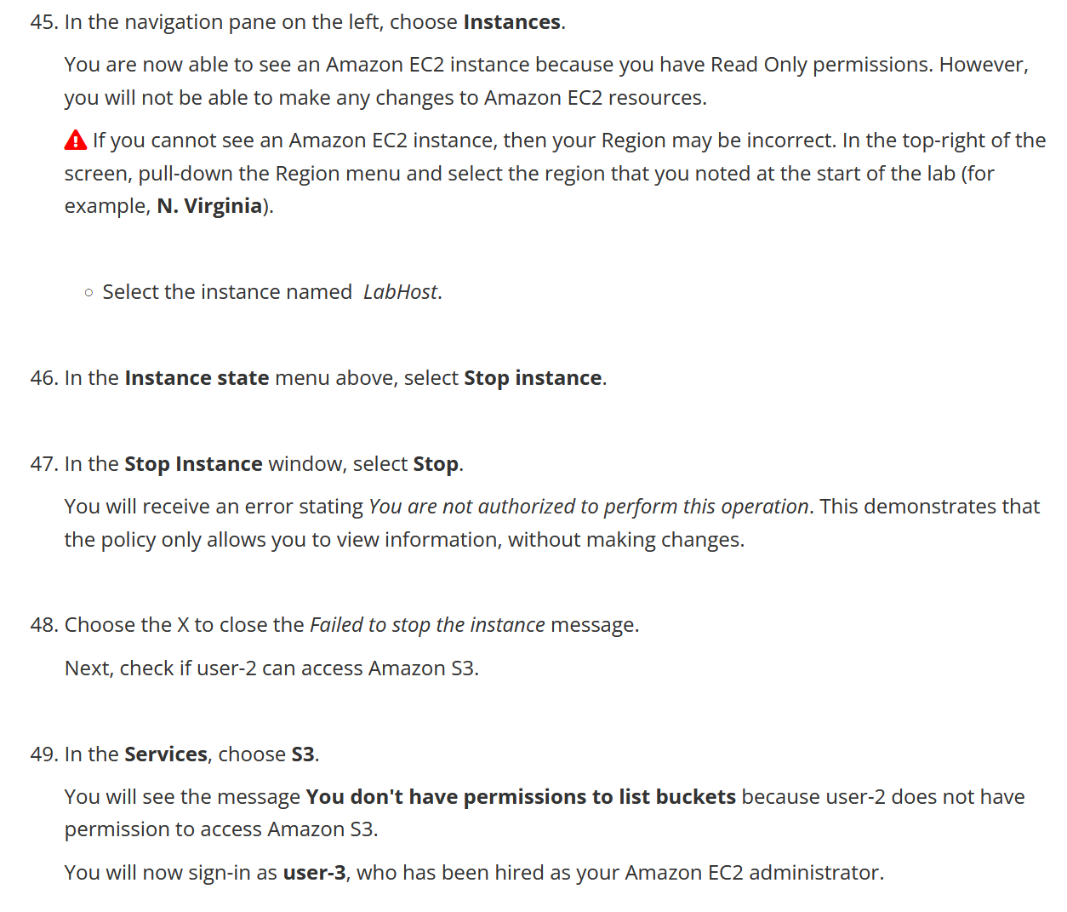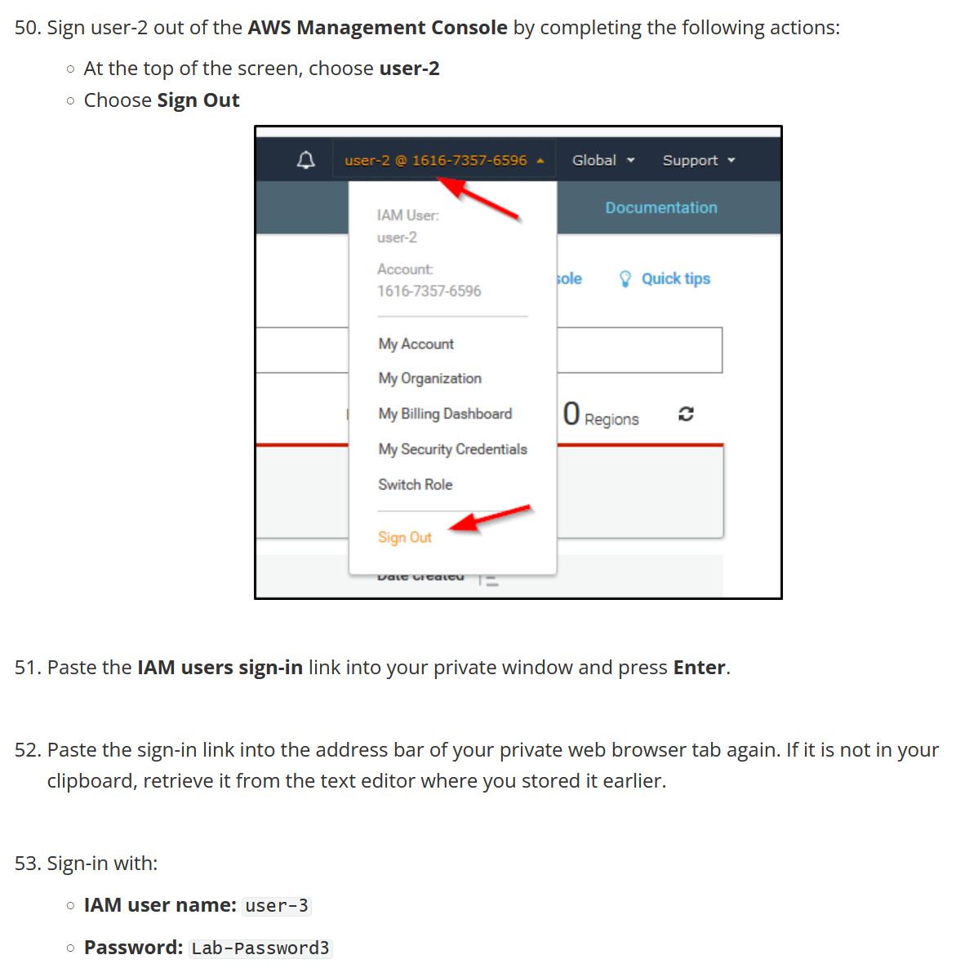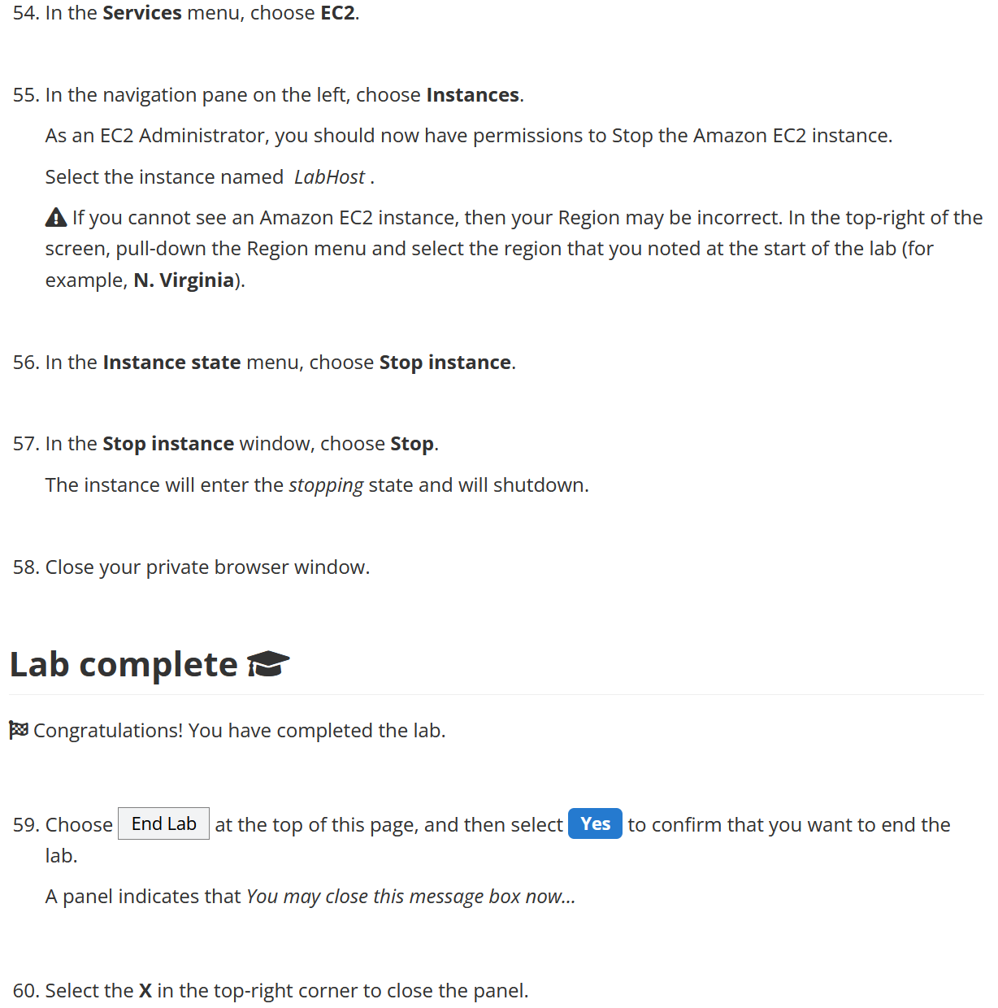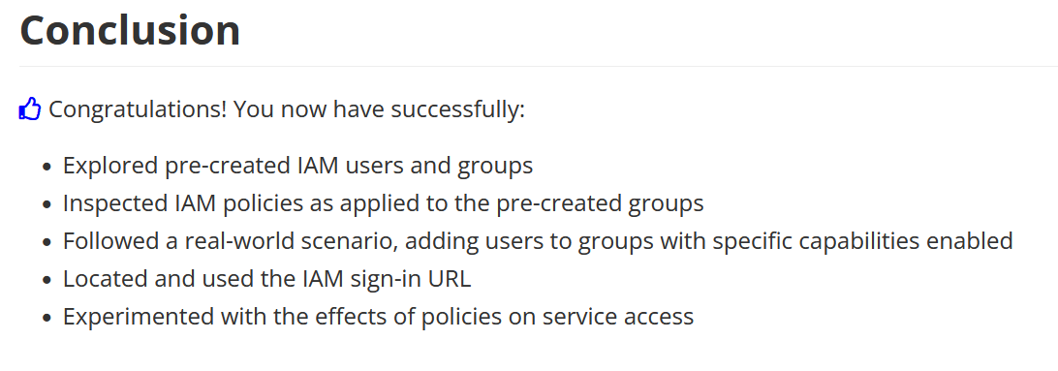

Lab 2

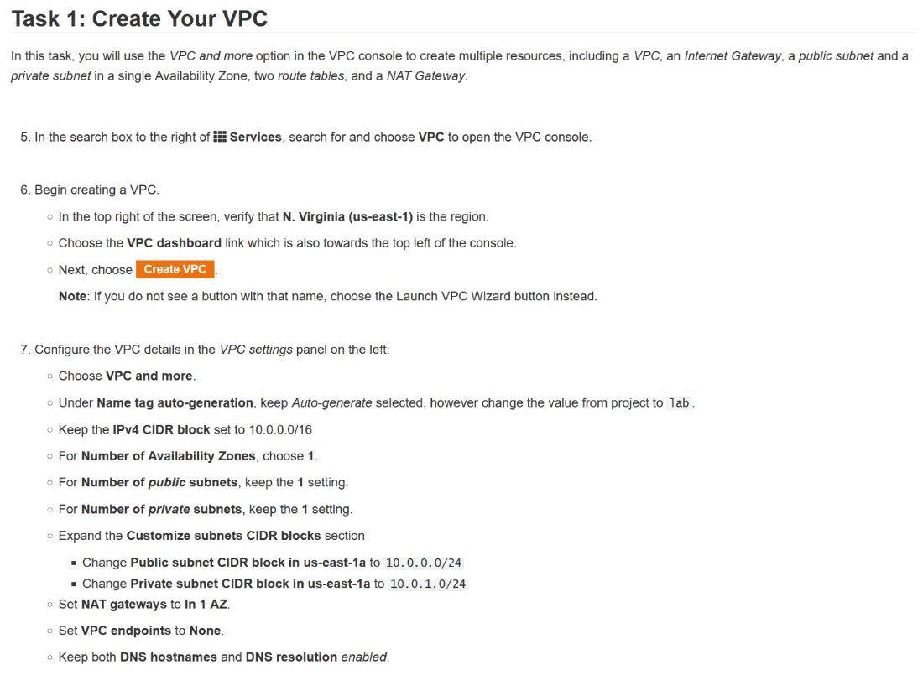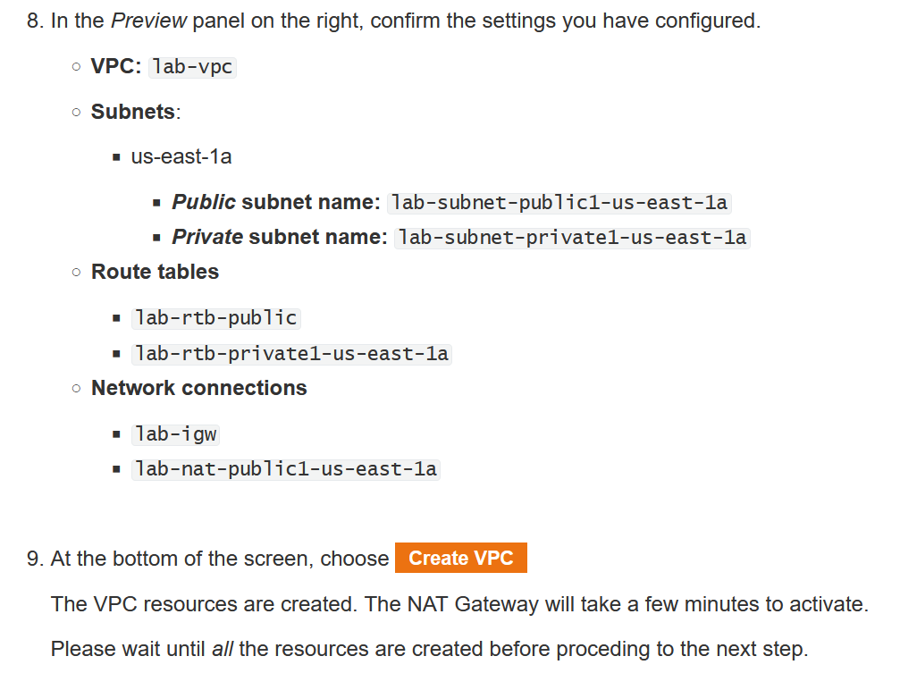

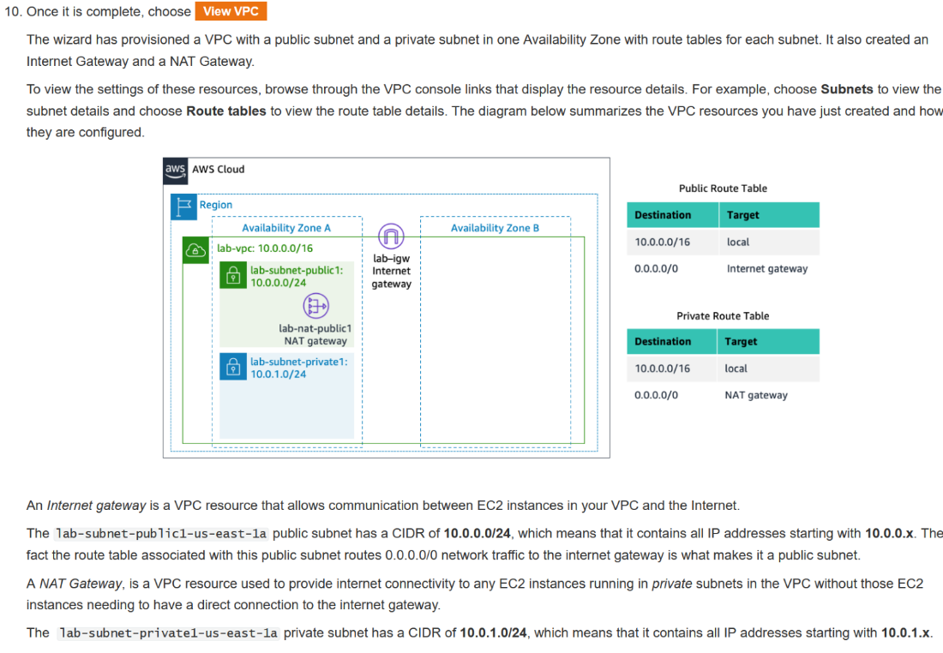

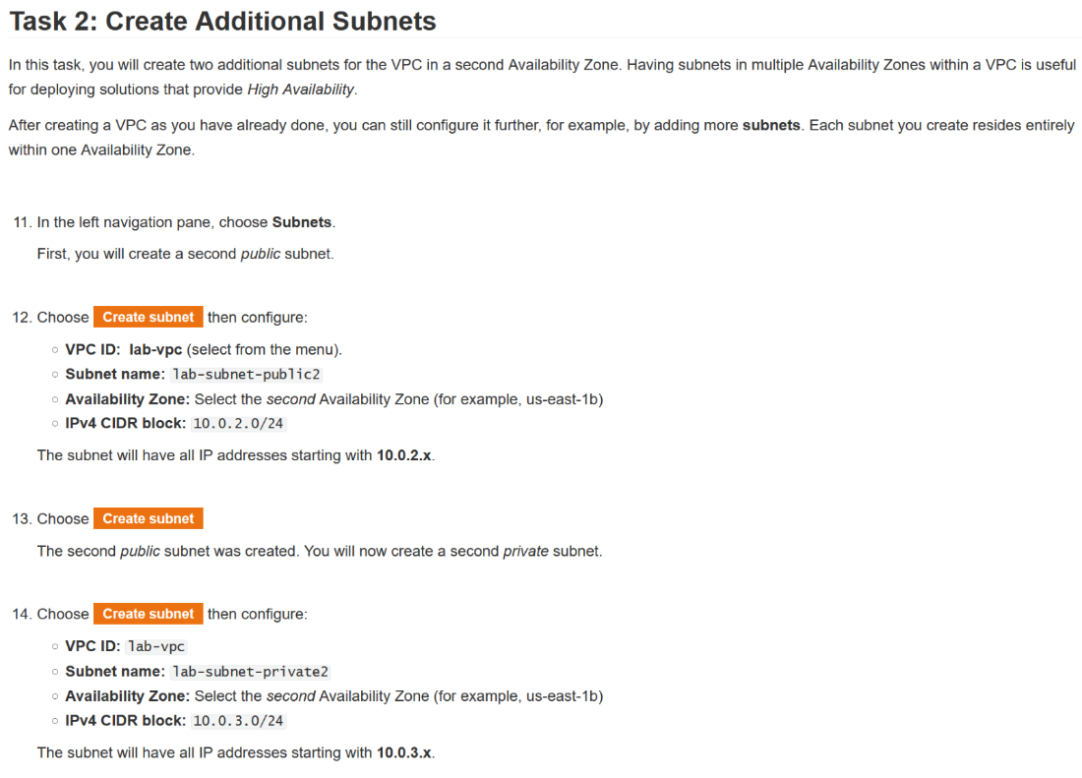

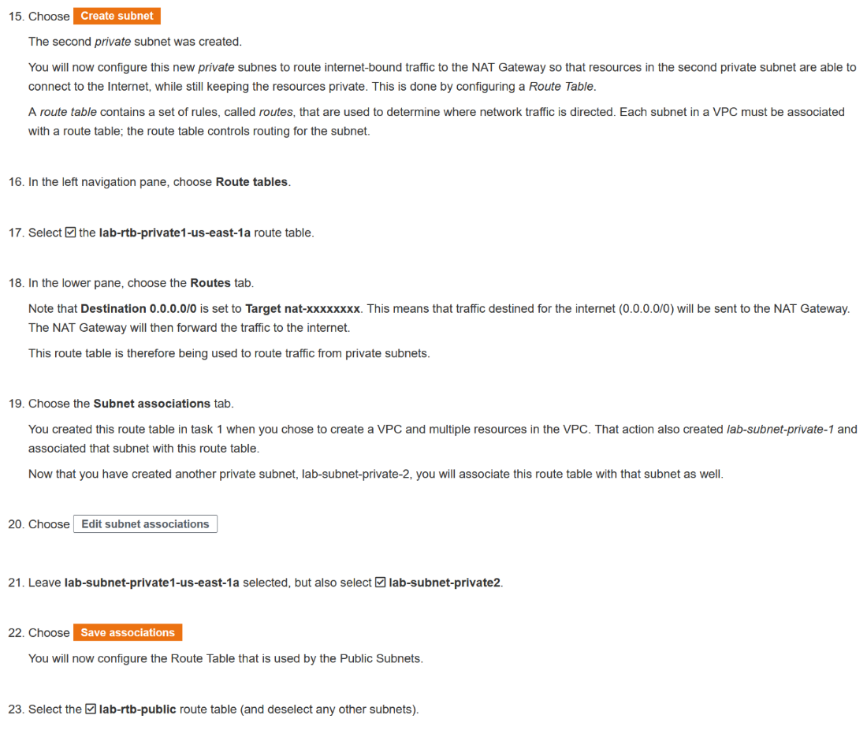

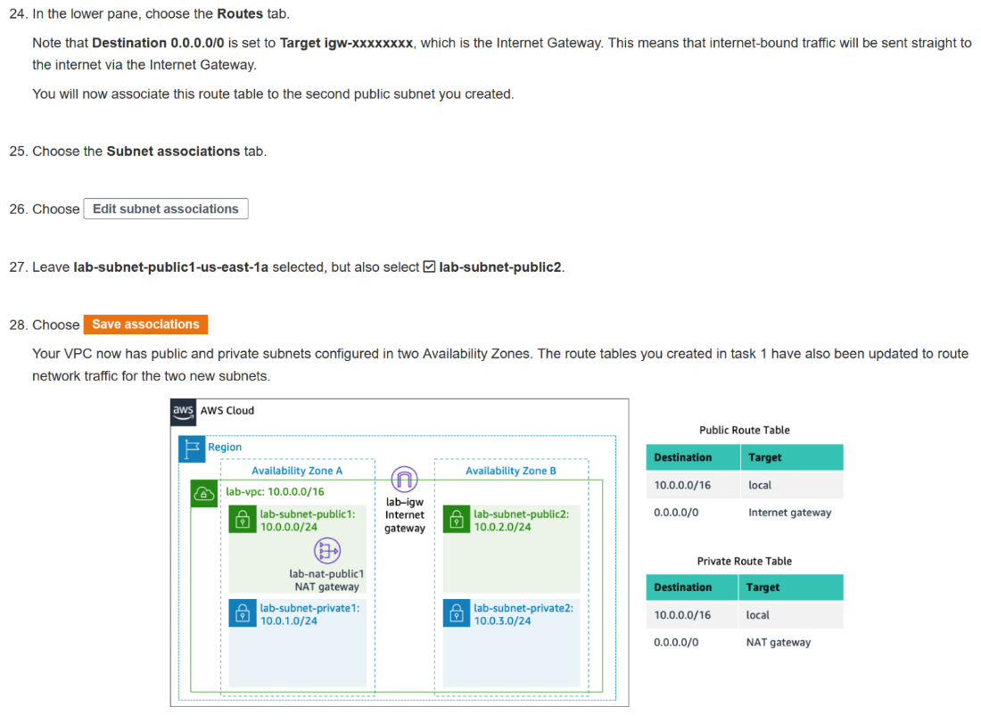

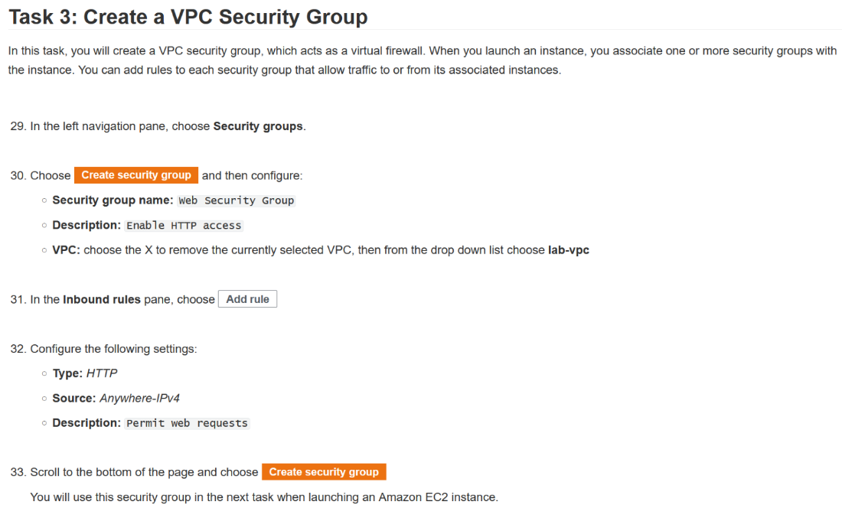

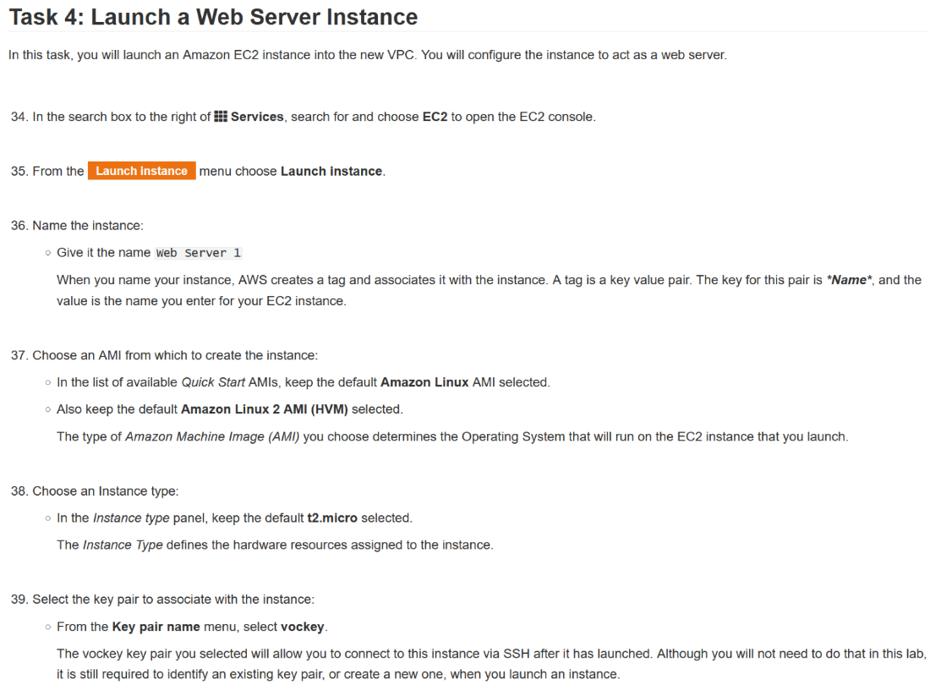

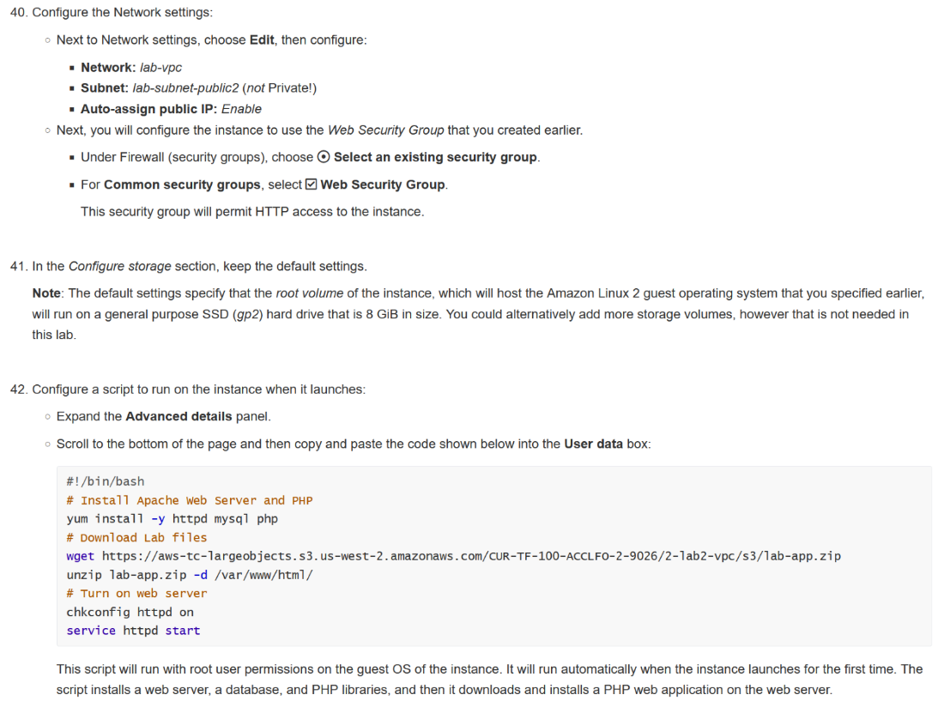

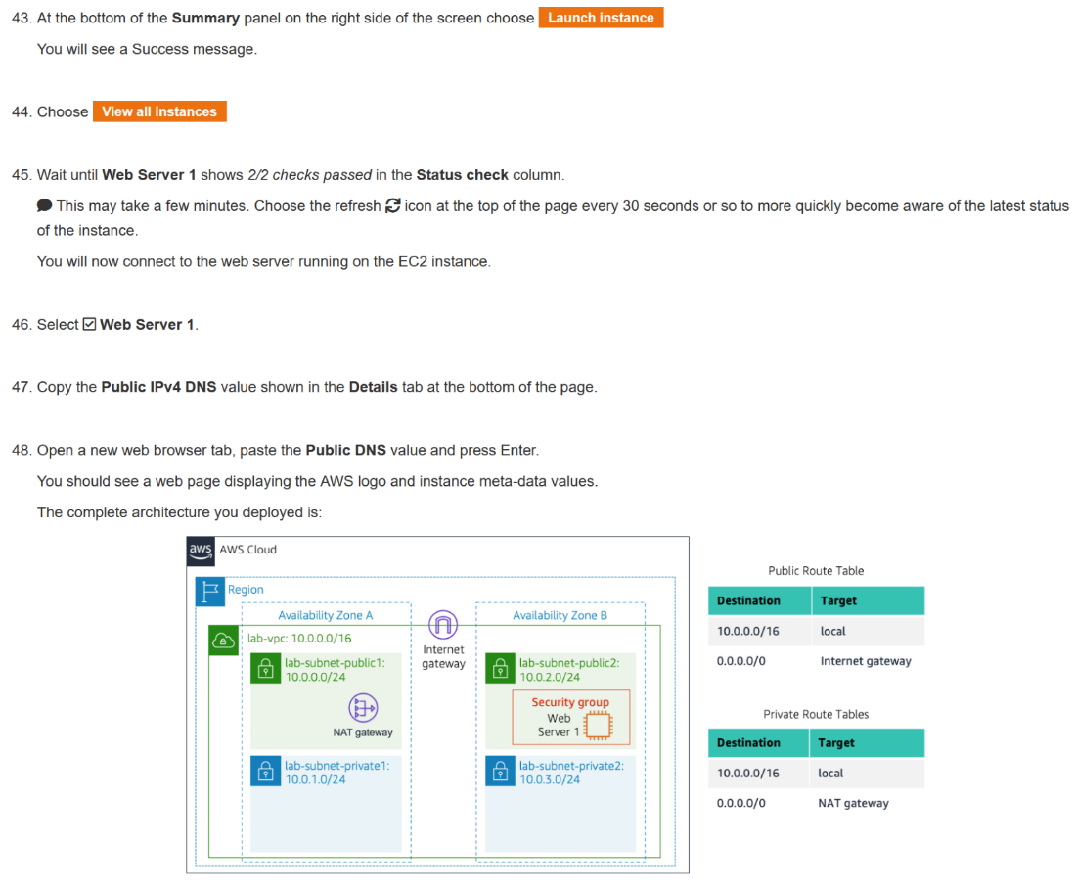

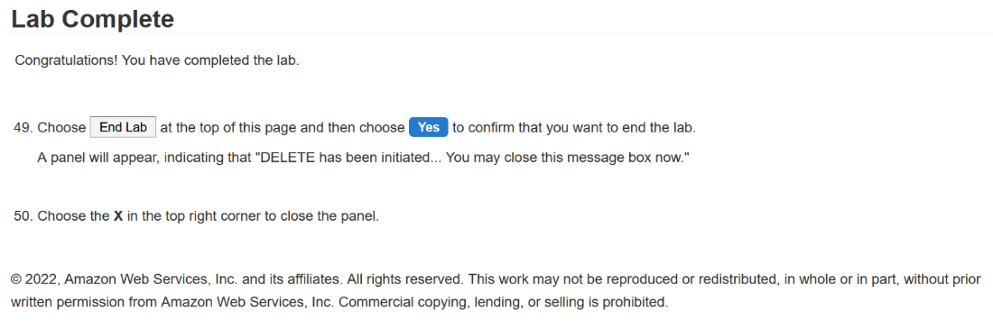

Lab 3

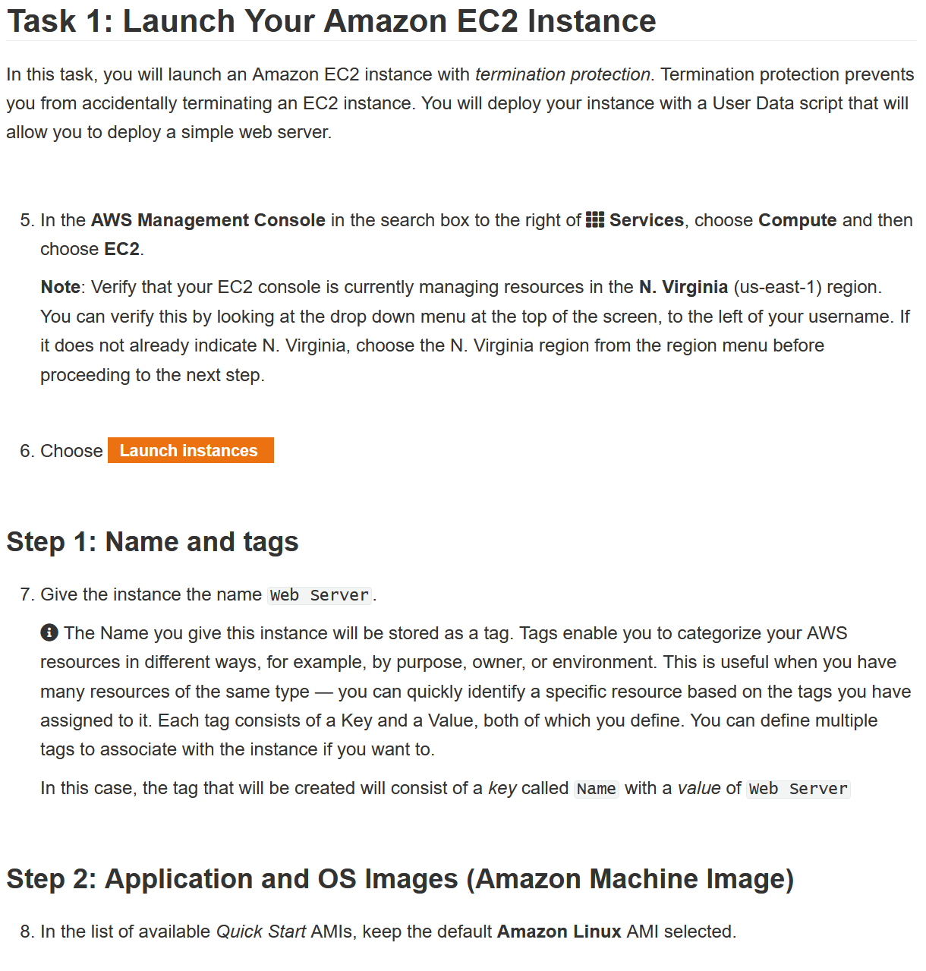

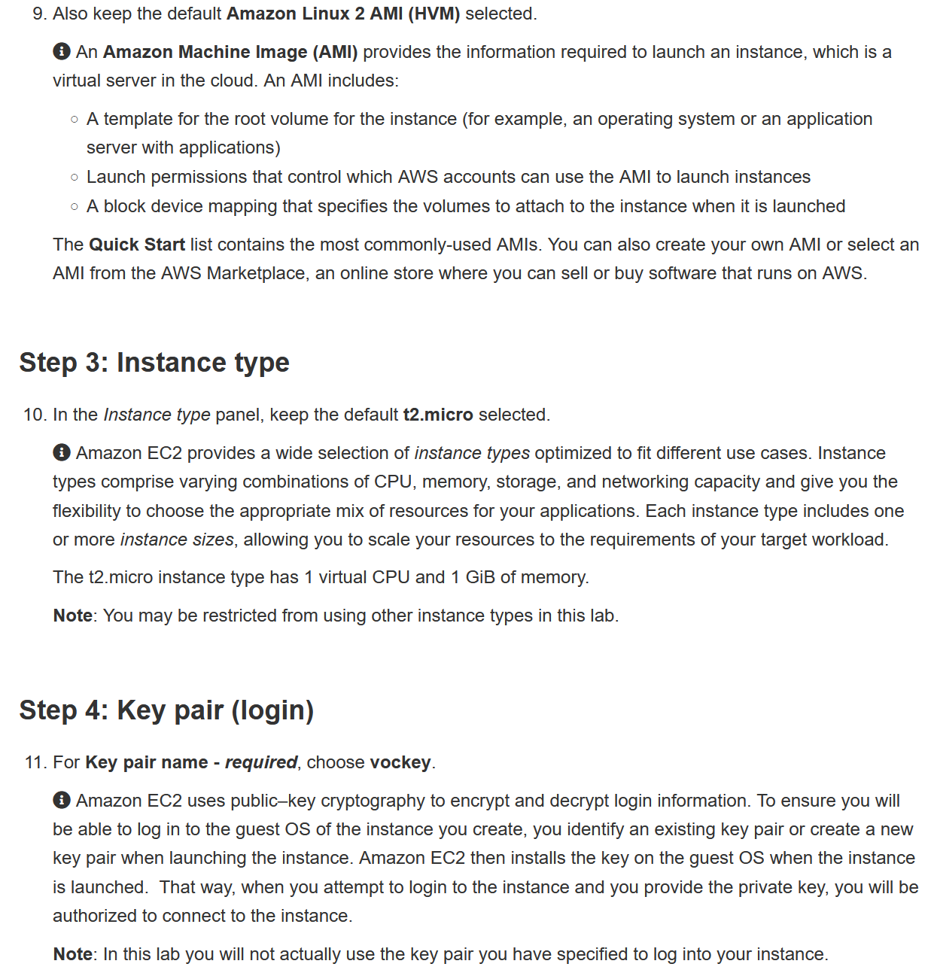

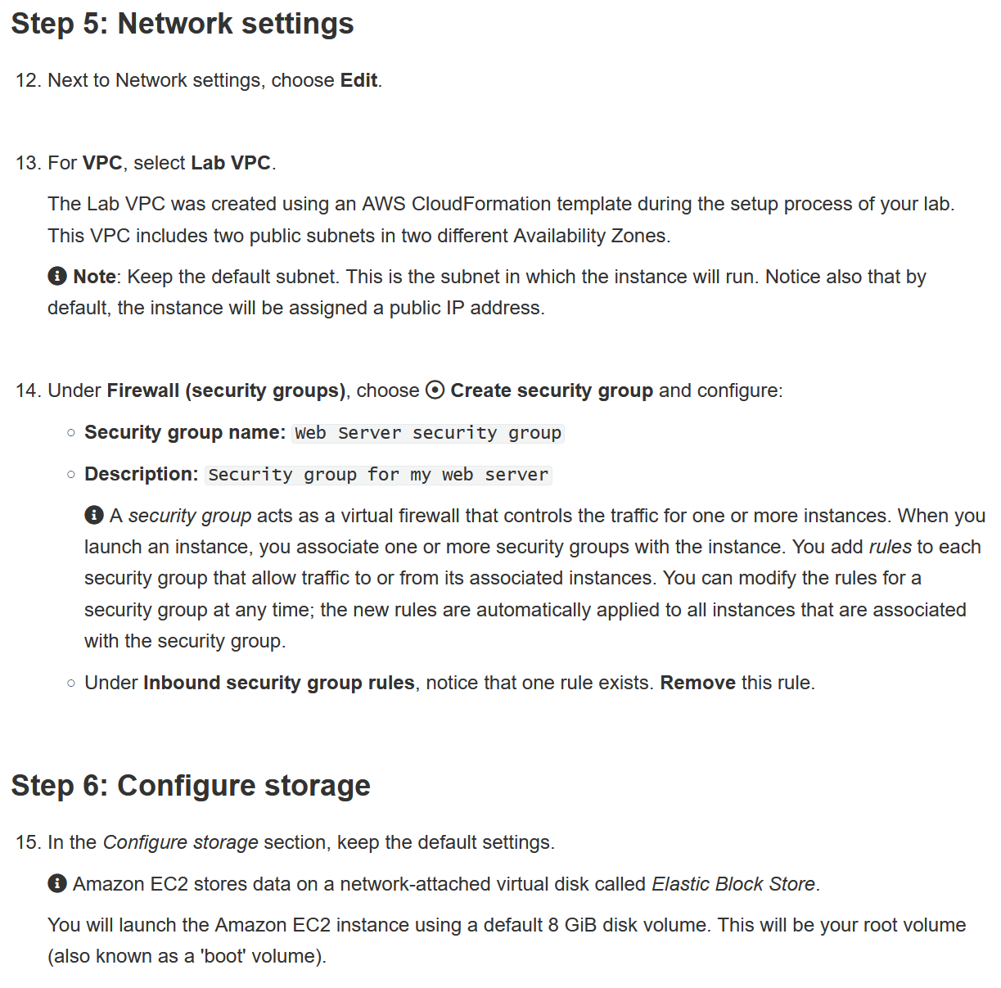

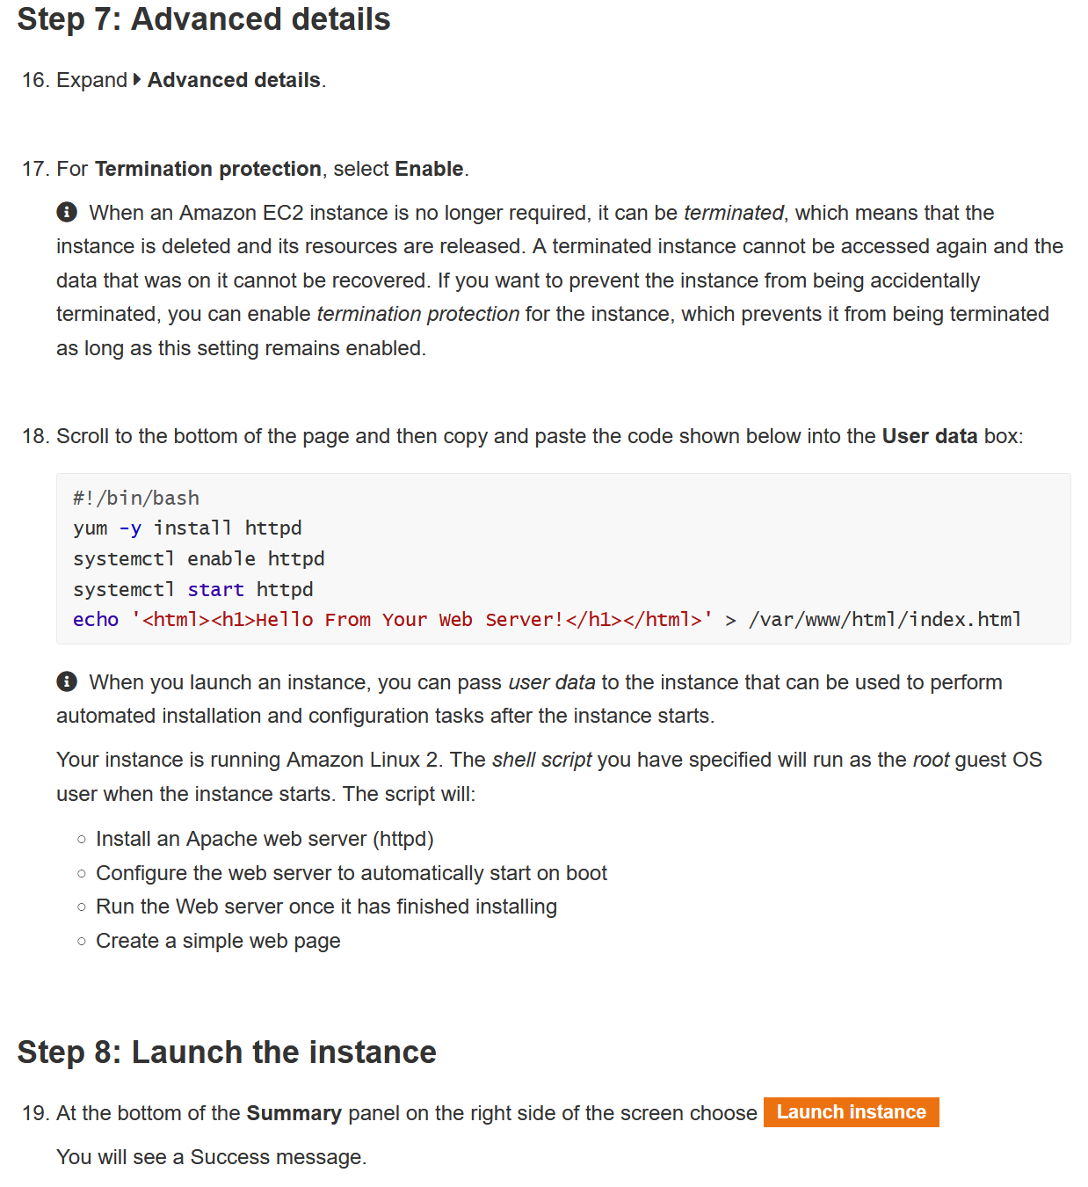

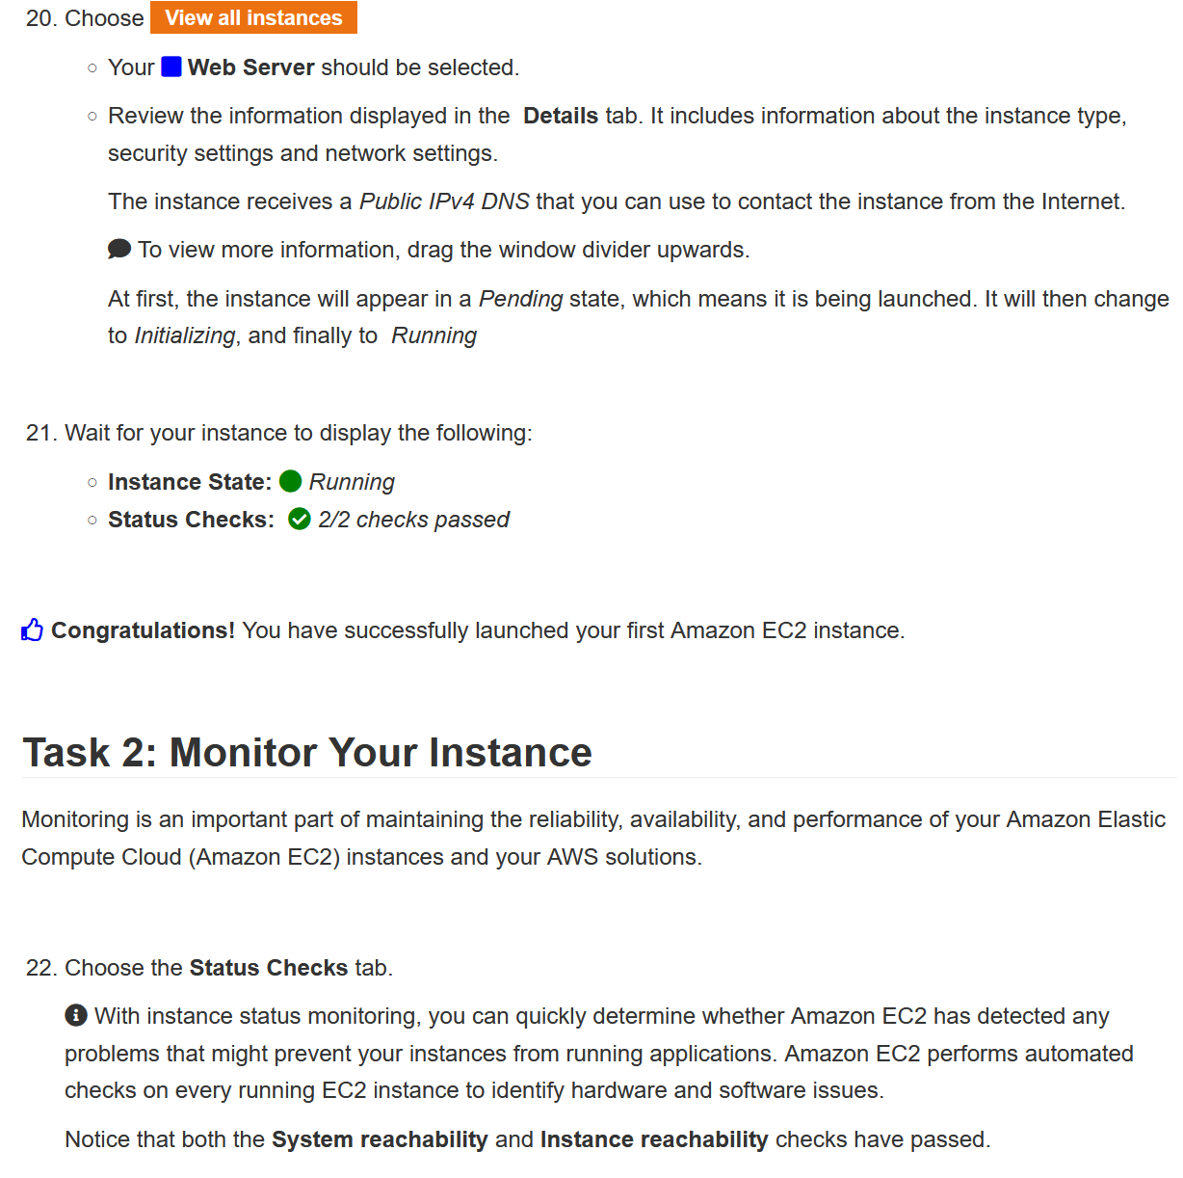

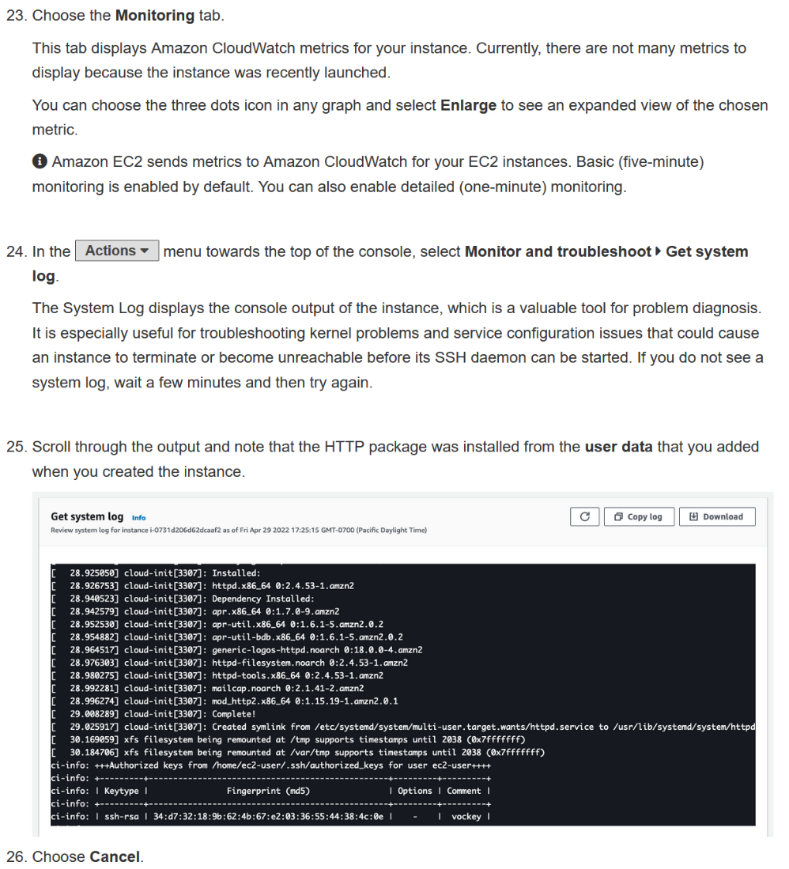

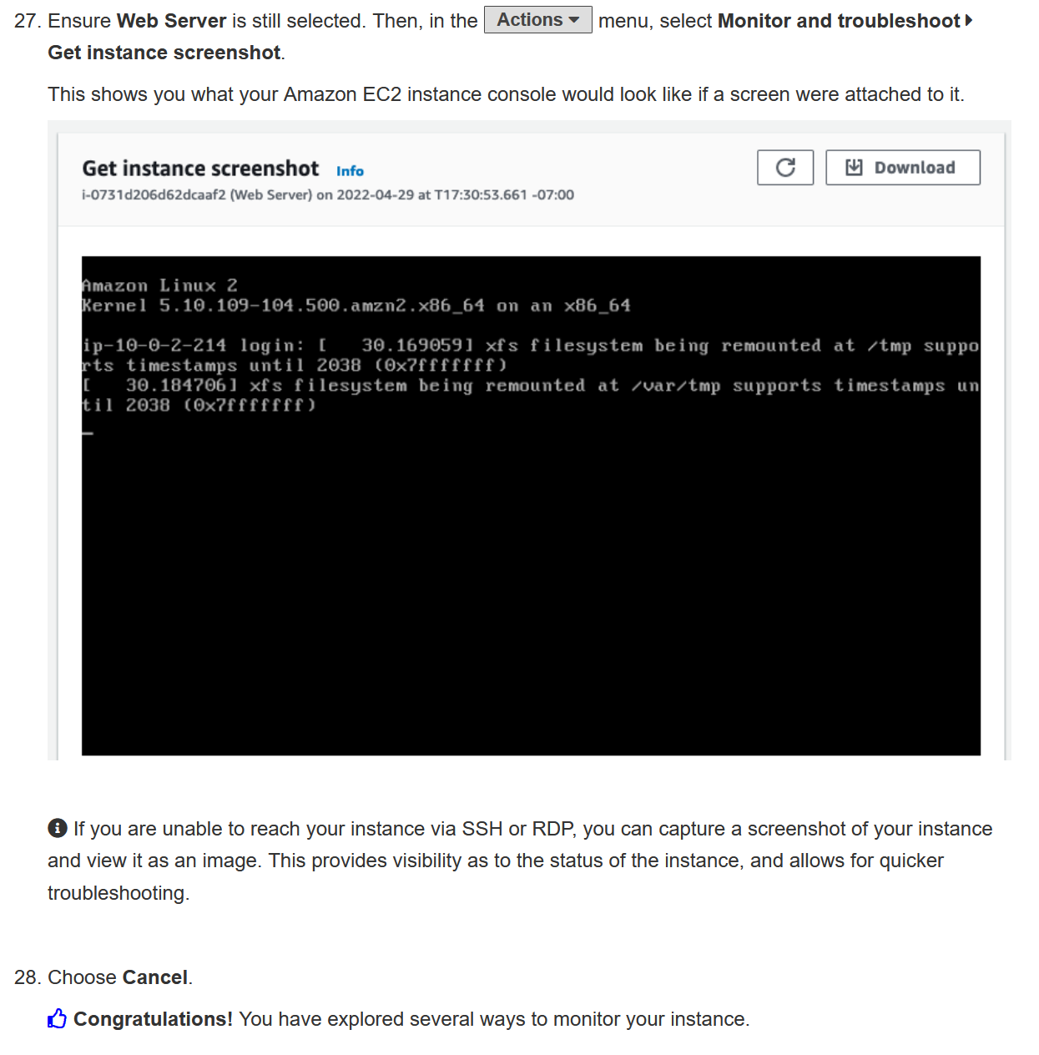

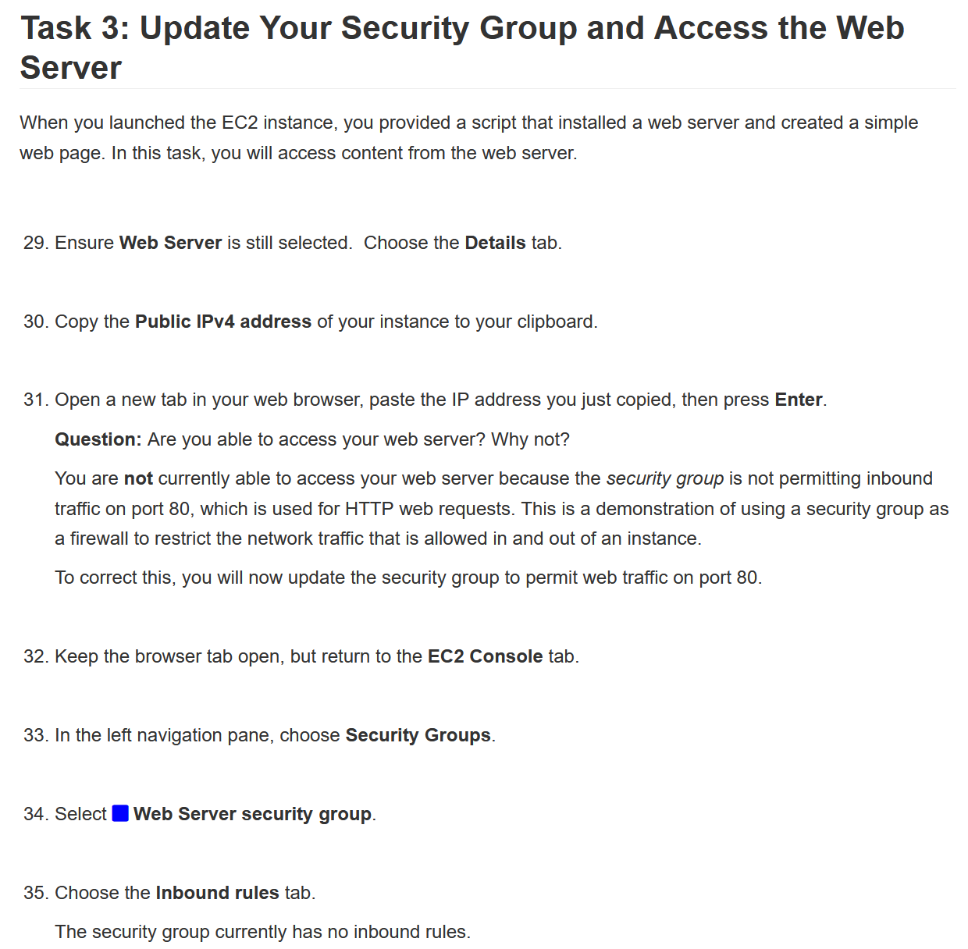

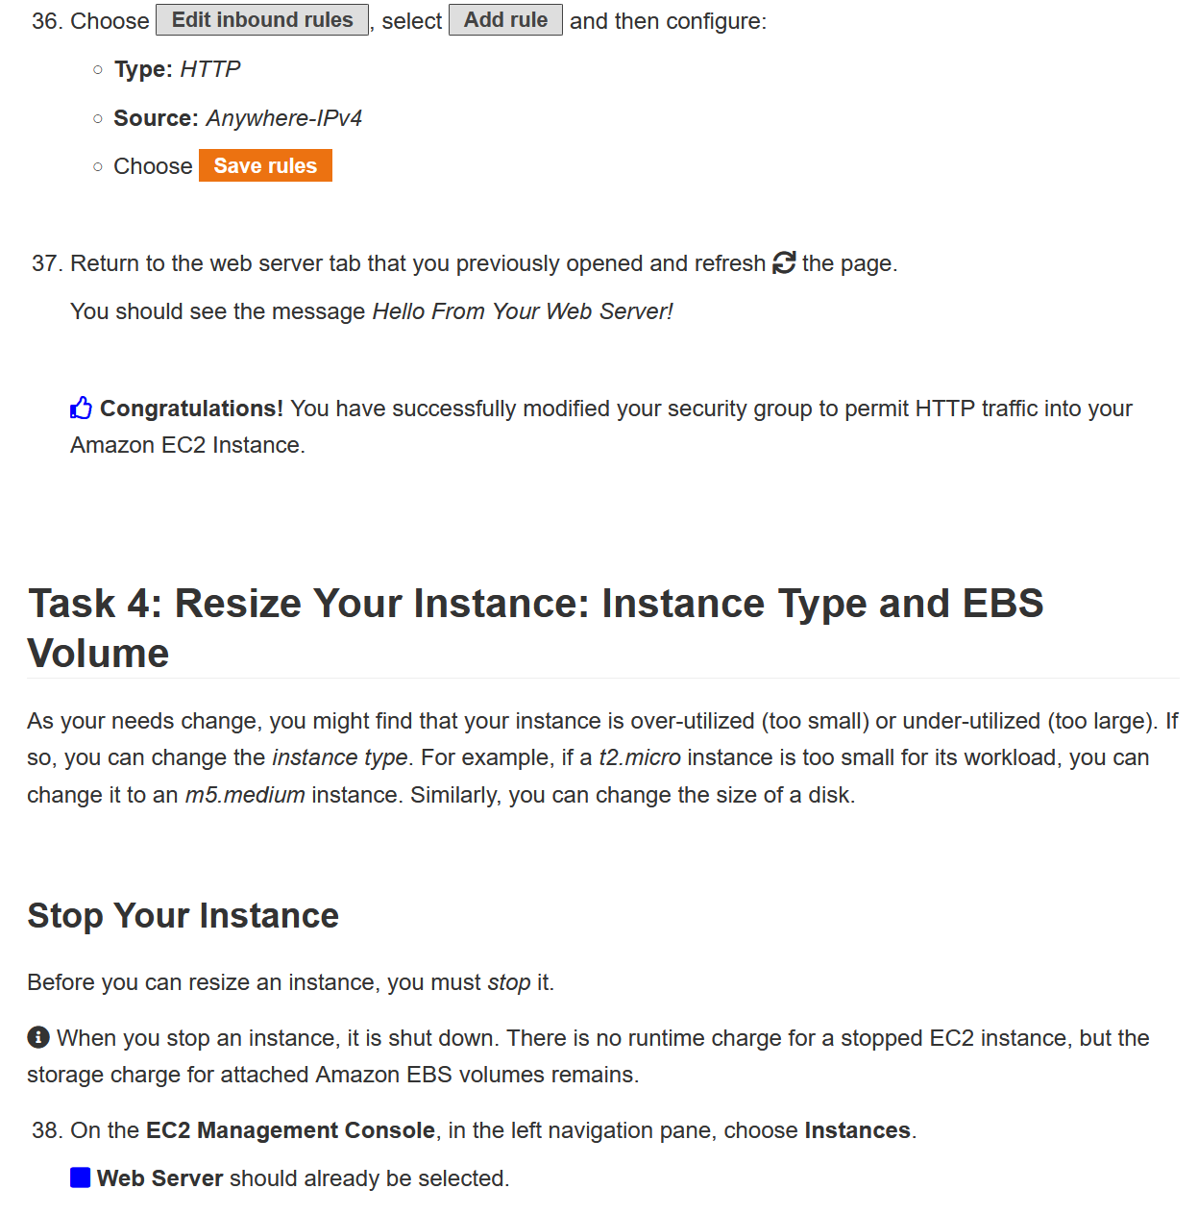

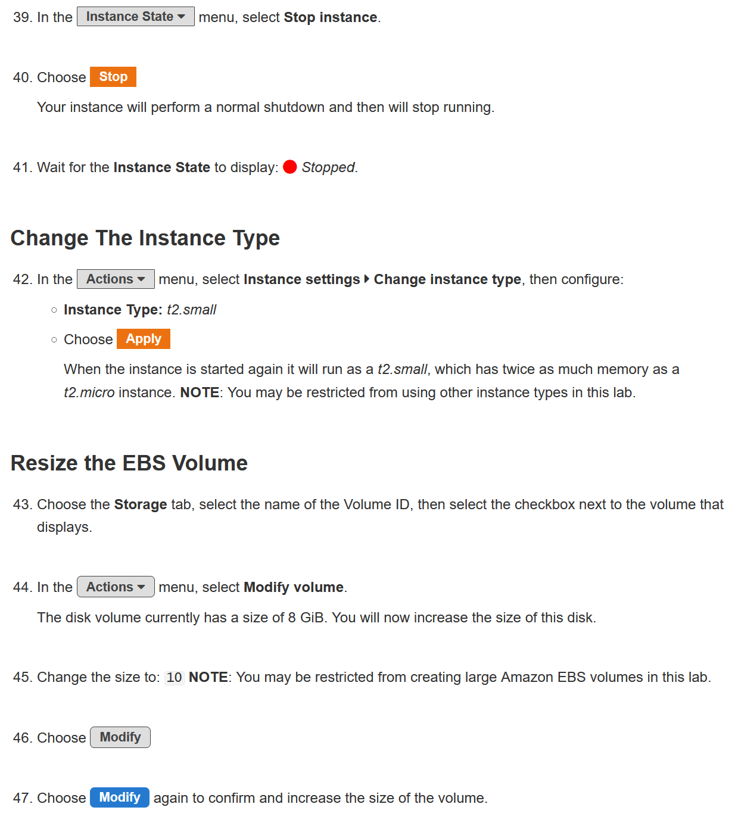

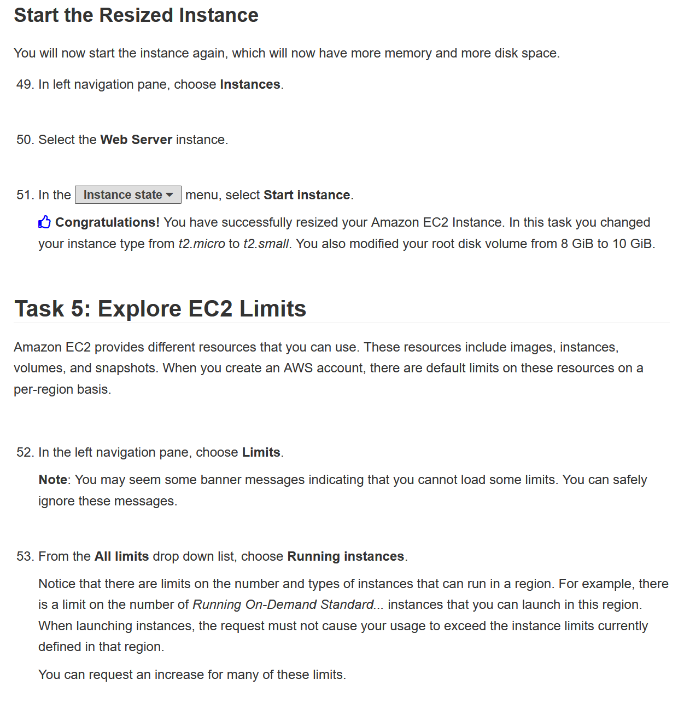

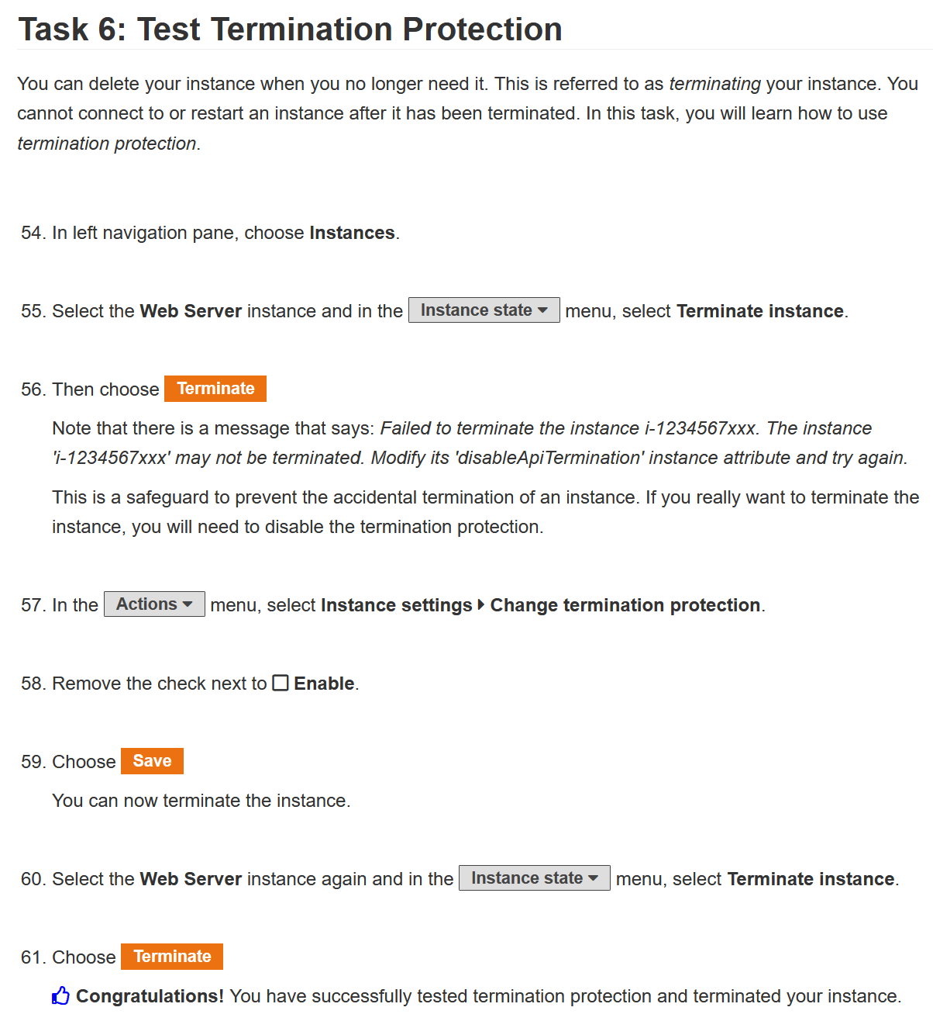

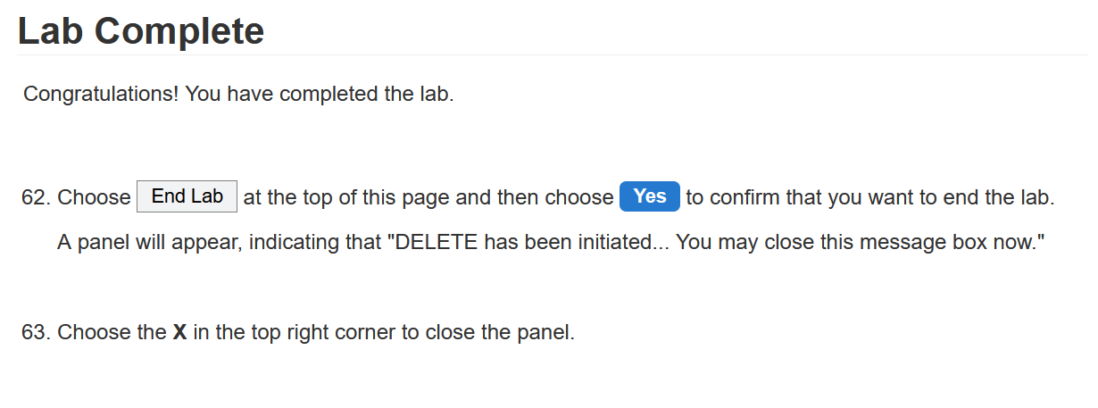

Here is the configuration for the lab. Like the diagram and commands, there is no router for me to input “show run” or something on, so I will just show what I did to complete the lab in screenshots.

Lab 1

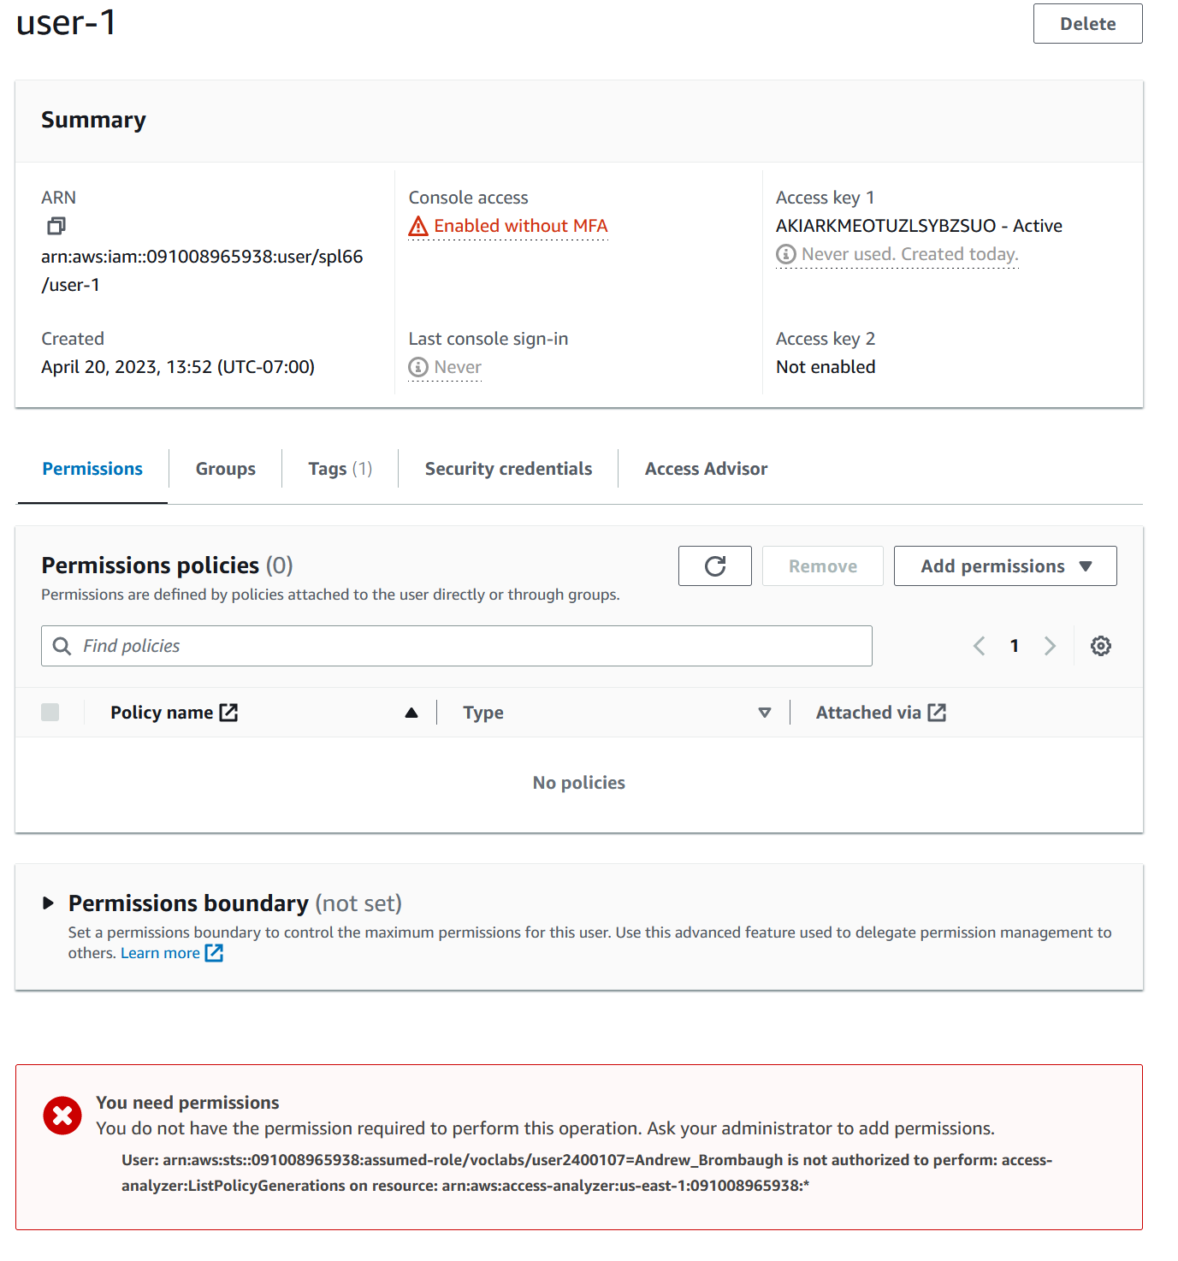

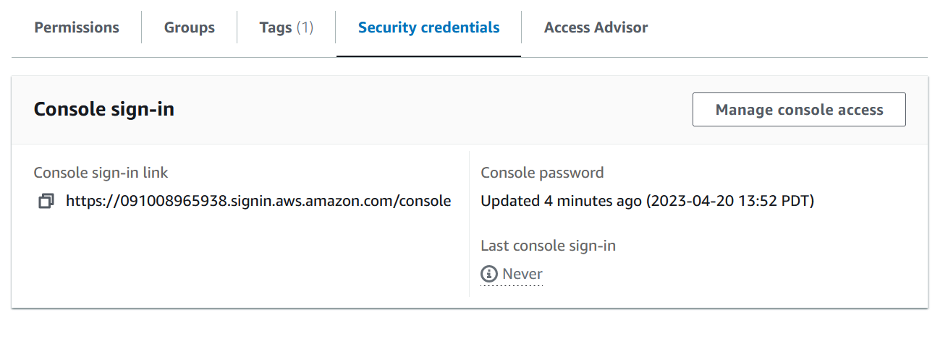

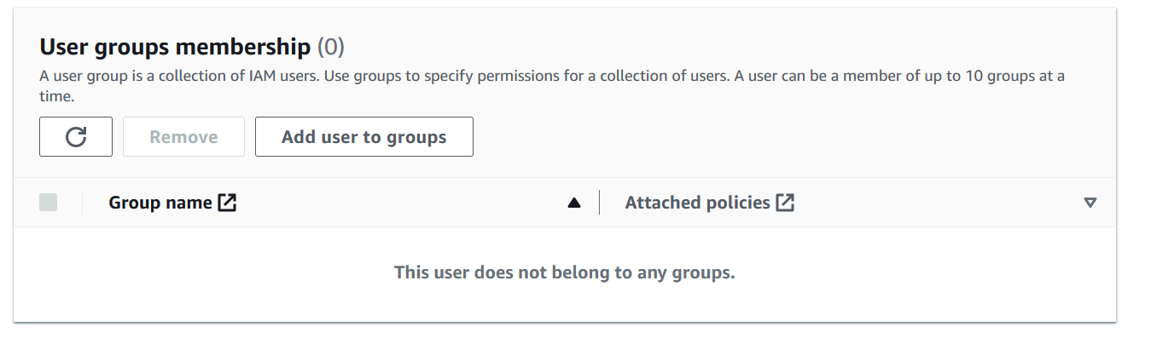

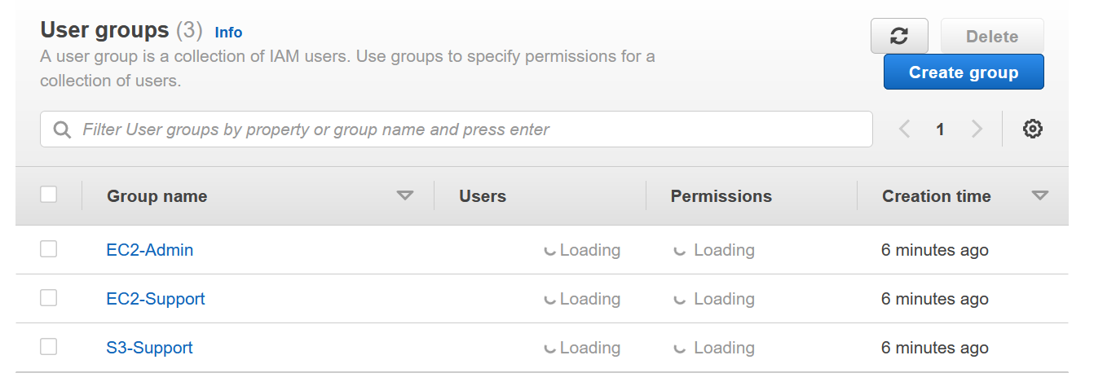

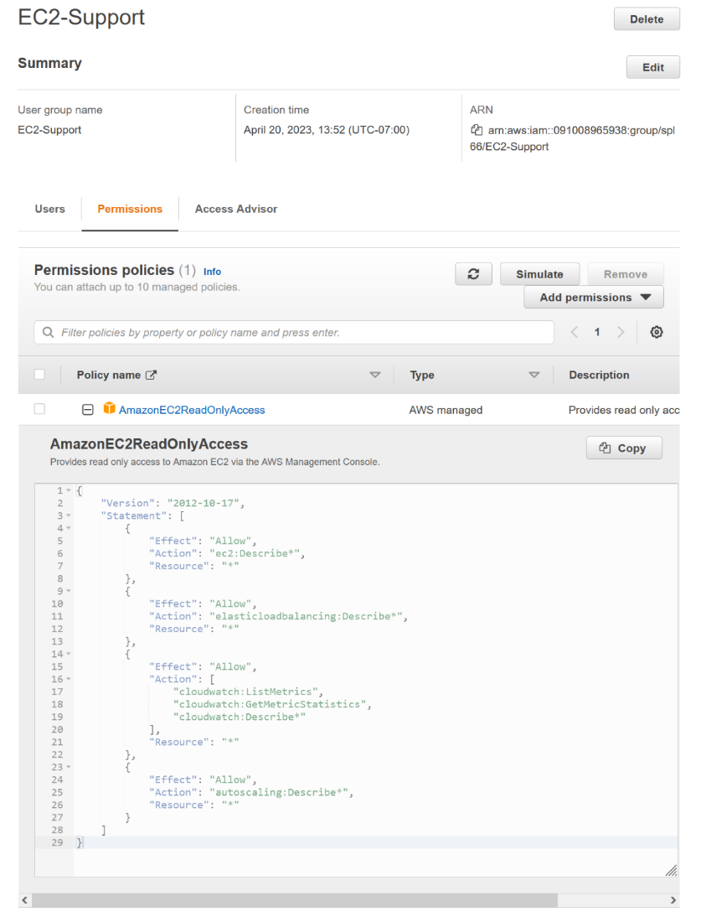

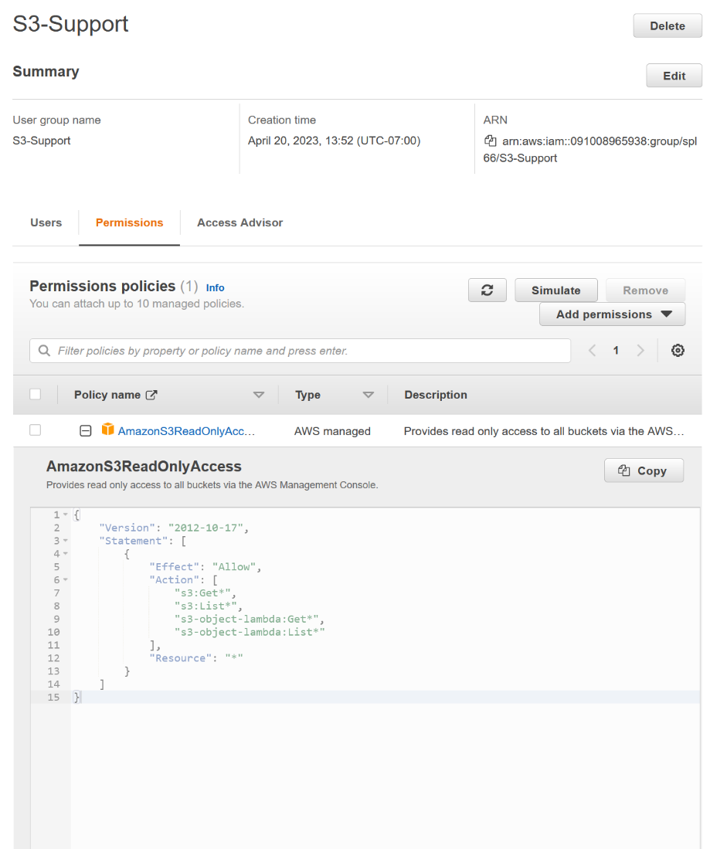

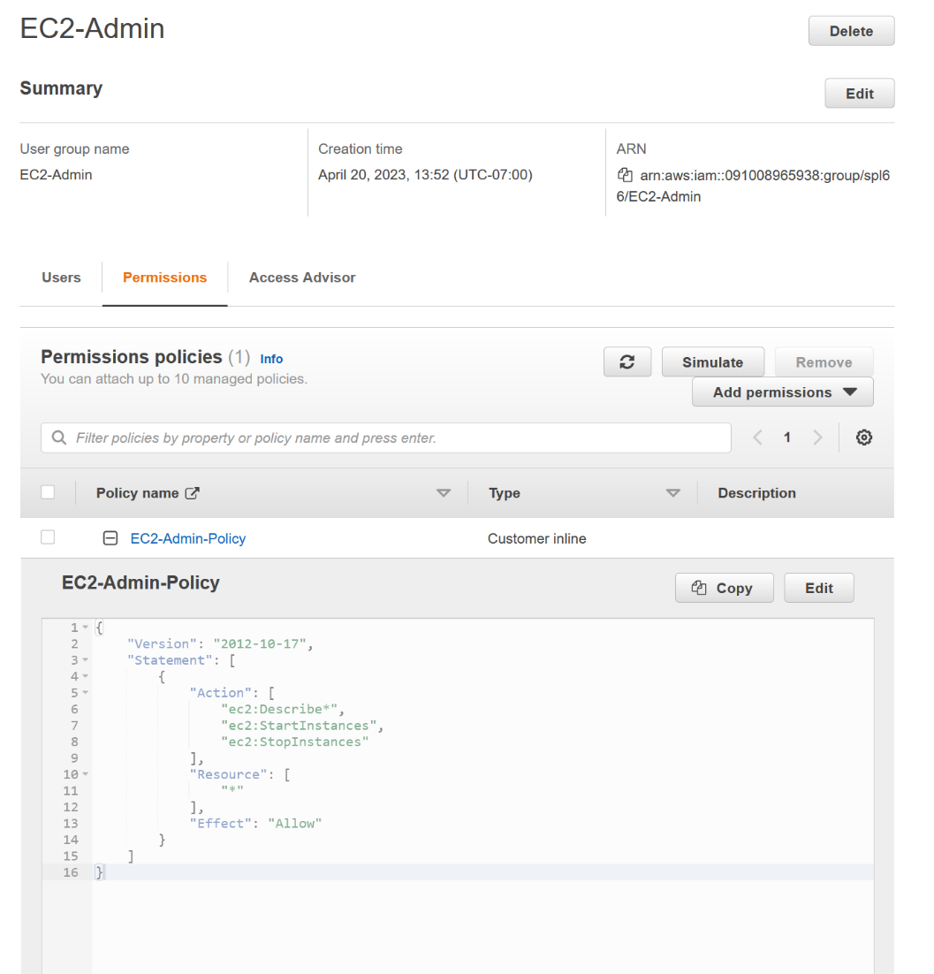

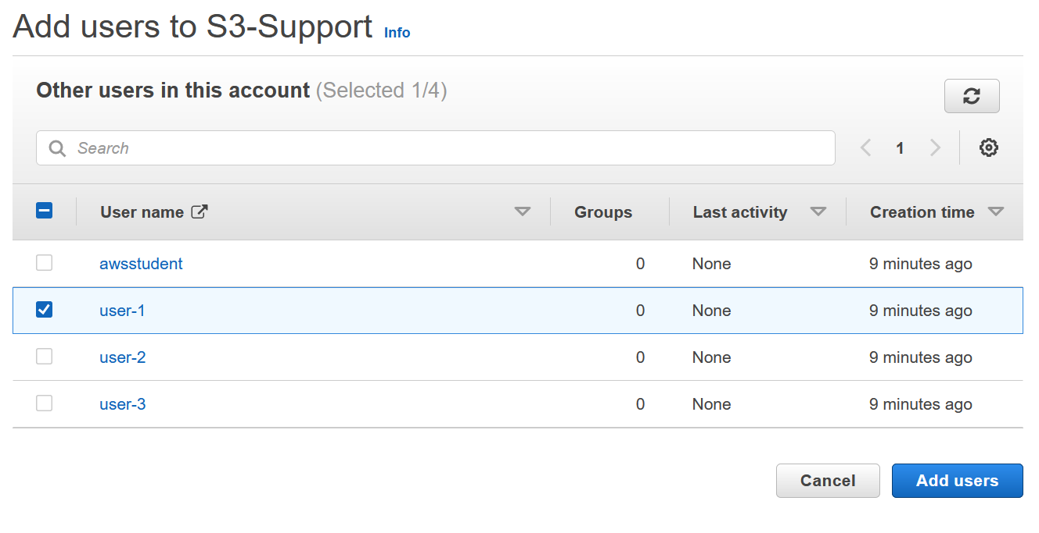

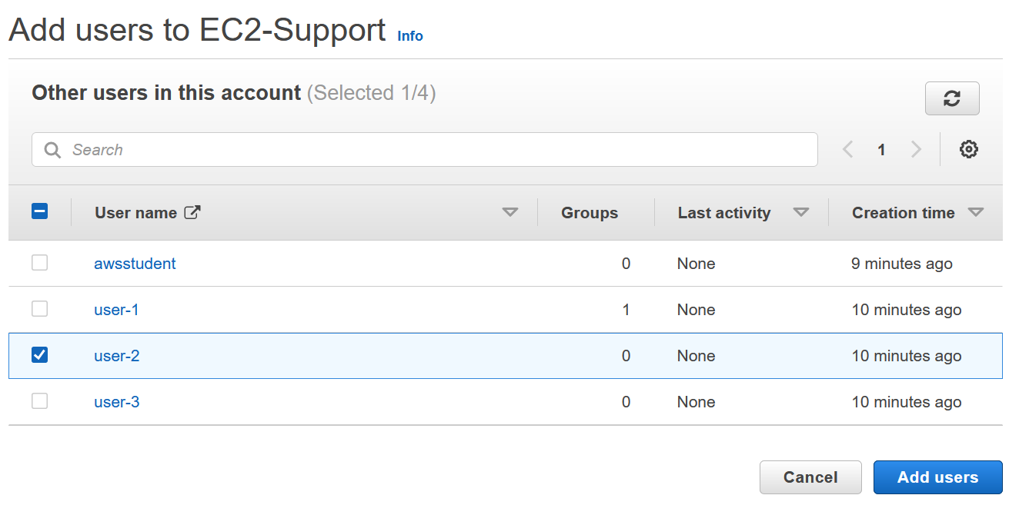

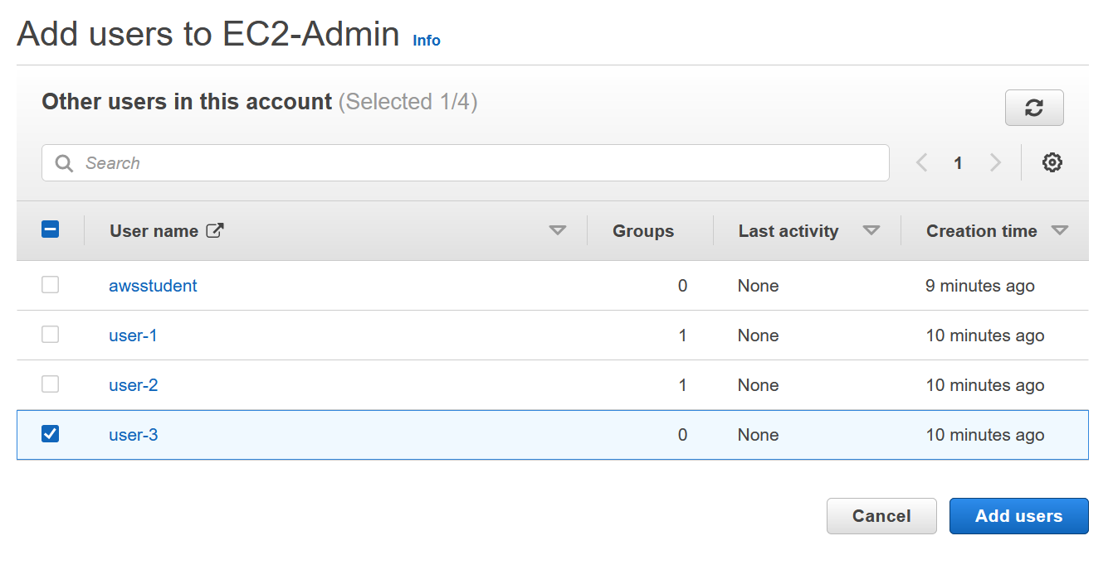

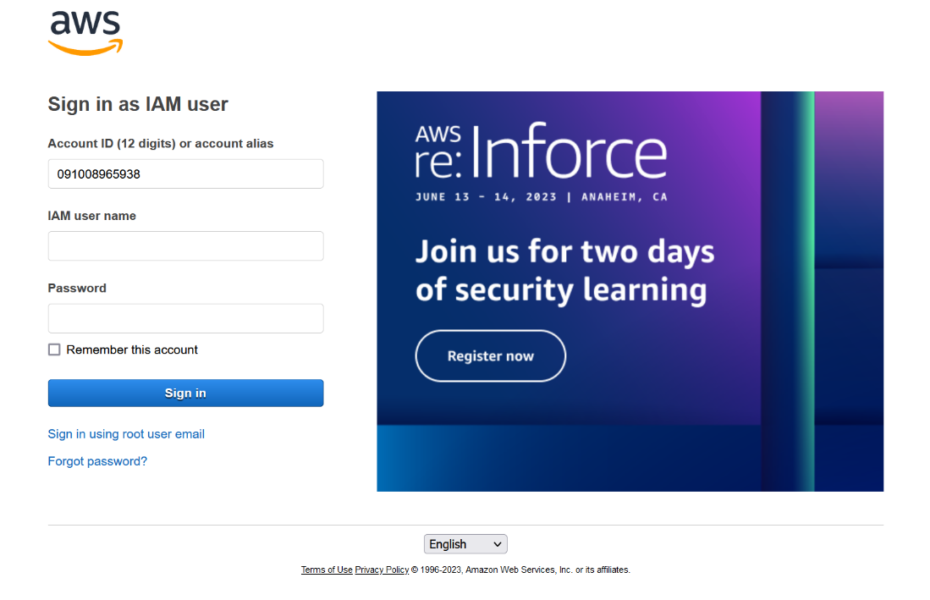

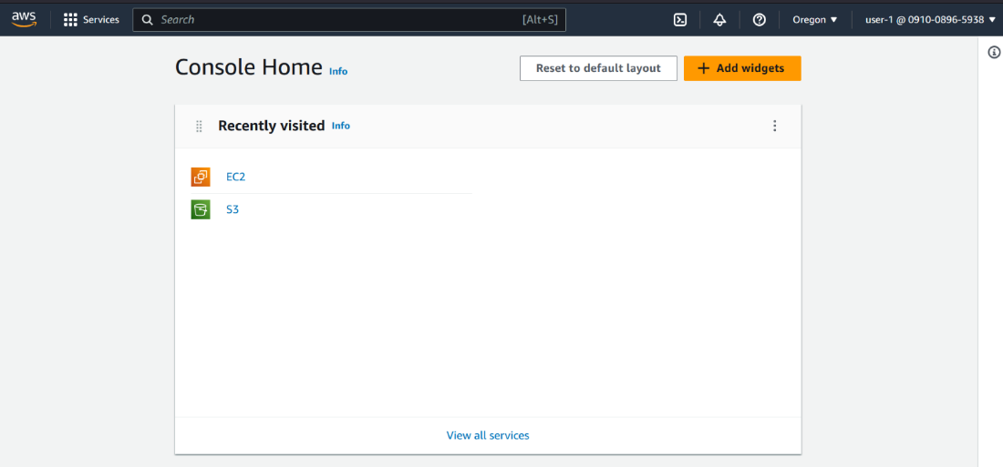

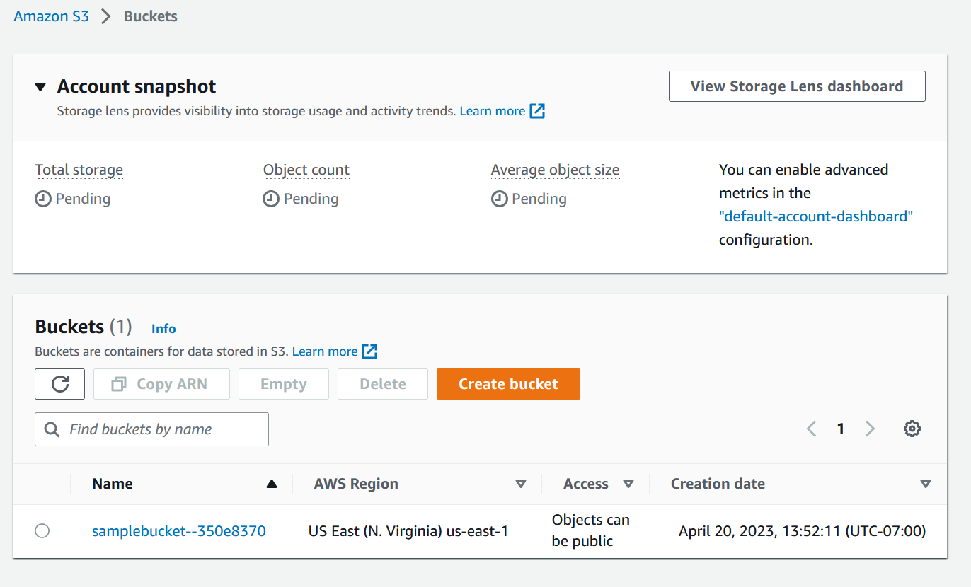

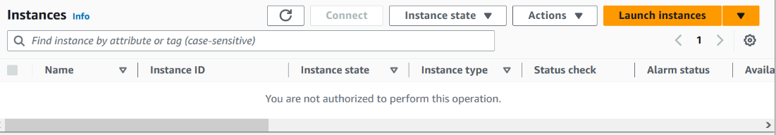

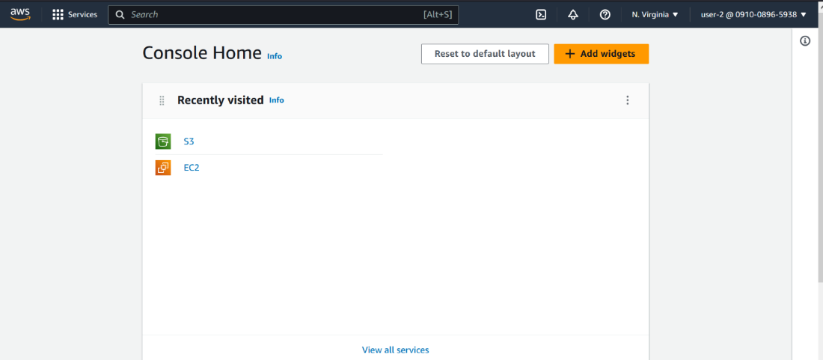

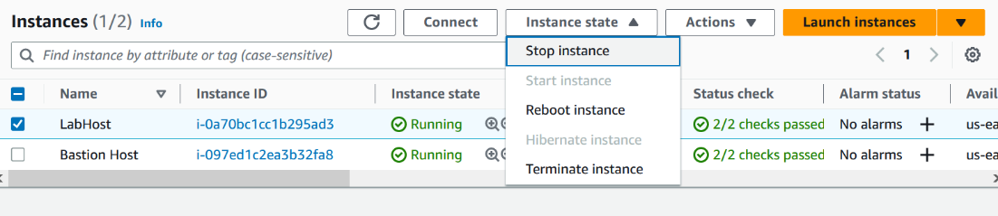

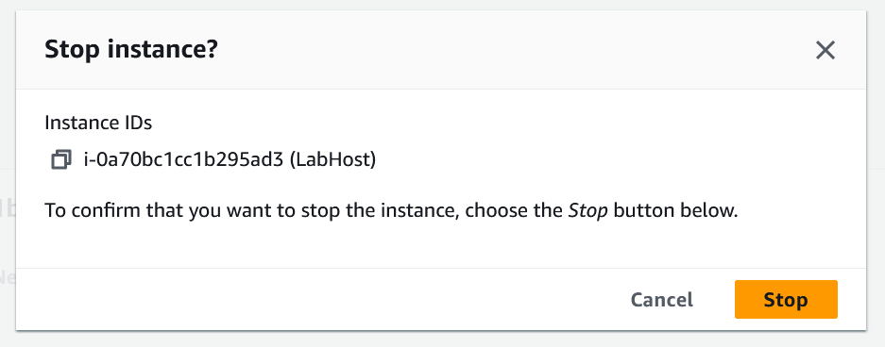



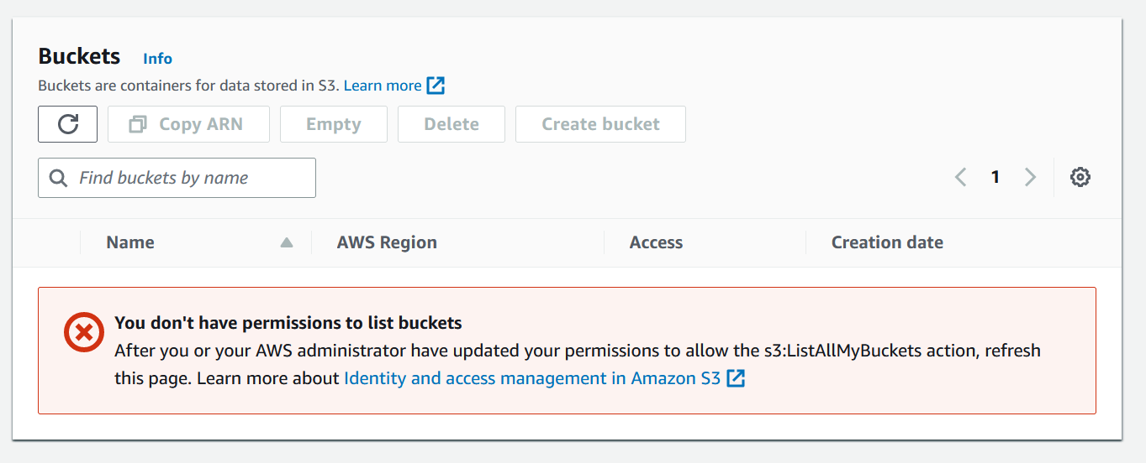

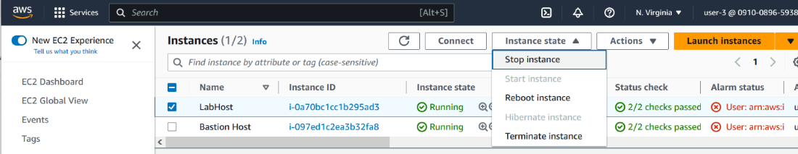  
Lab 2

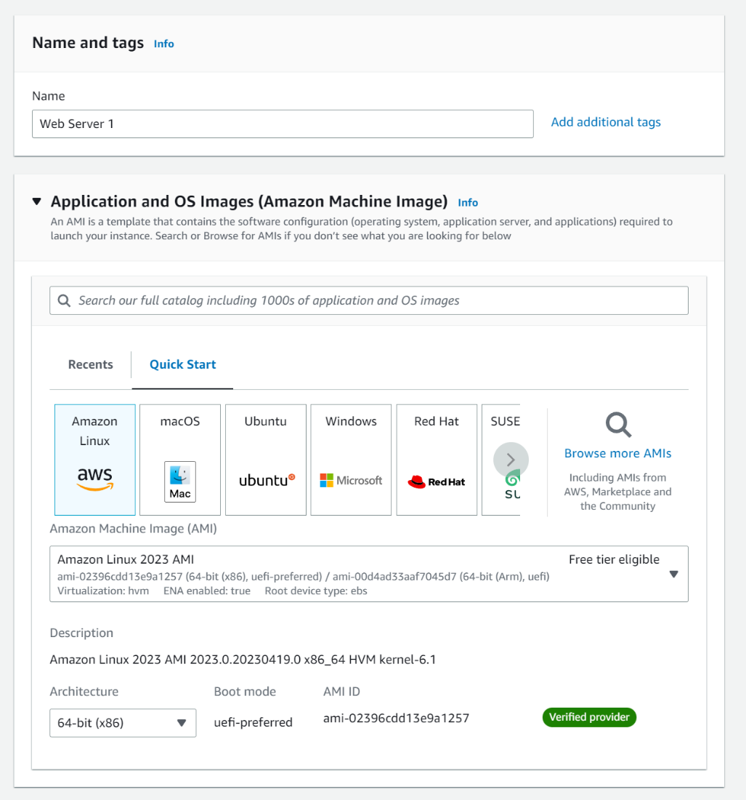

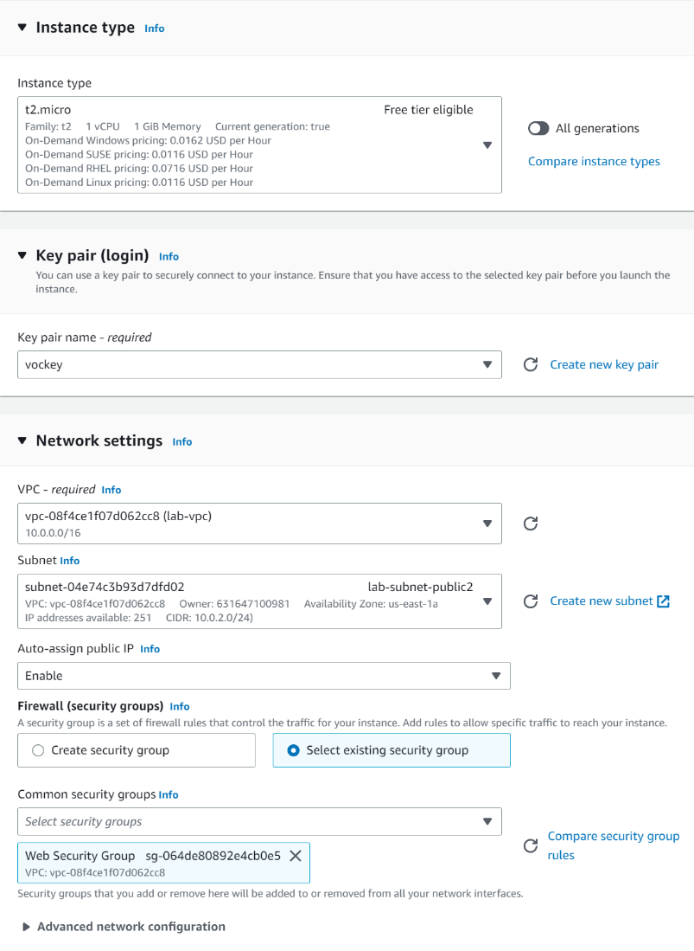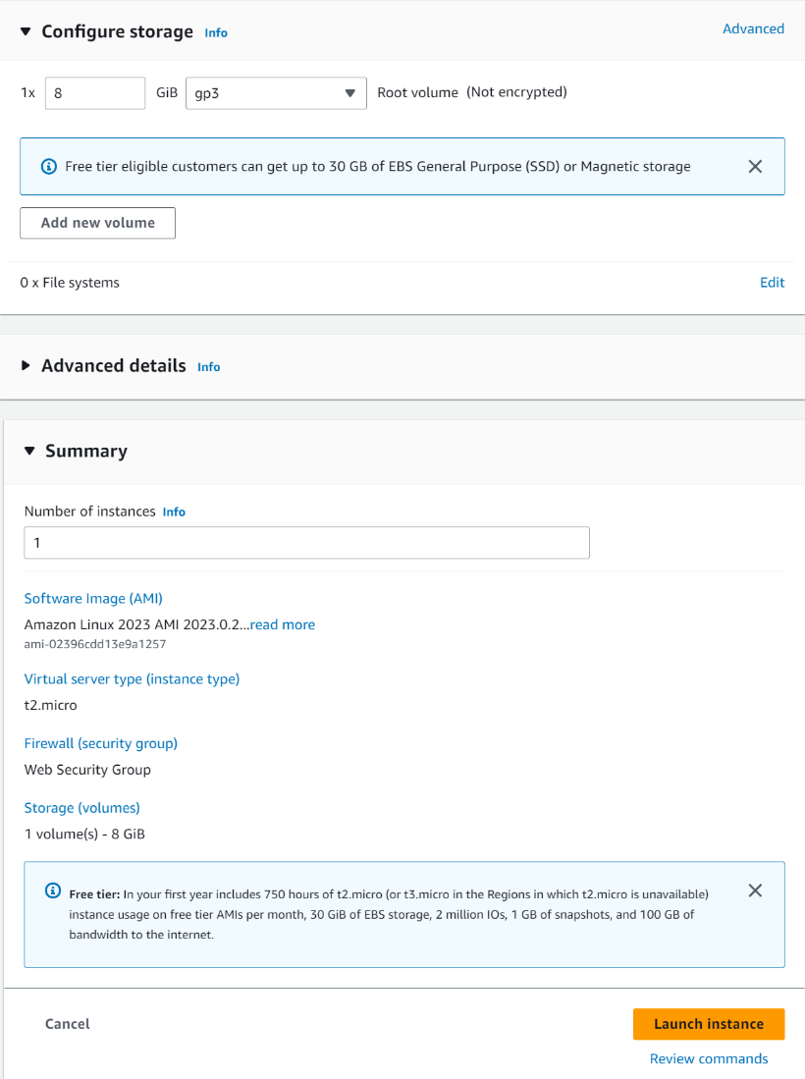

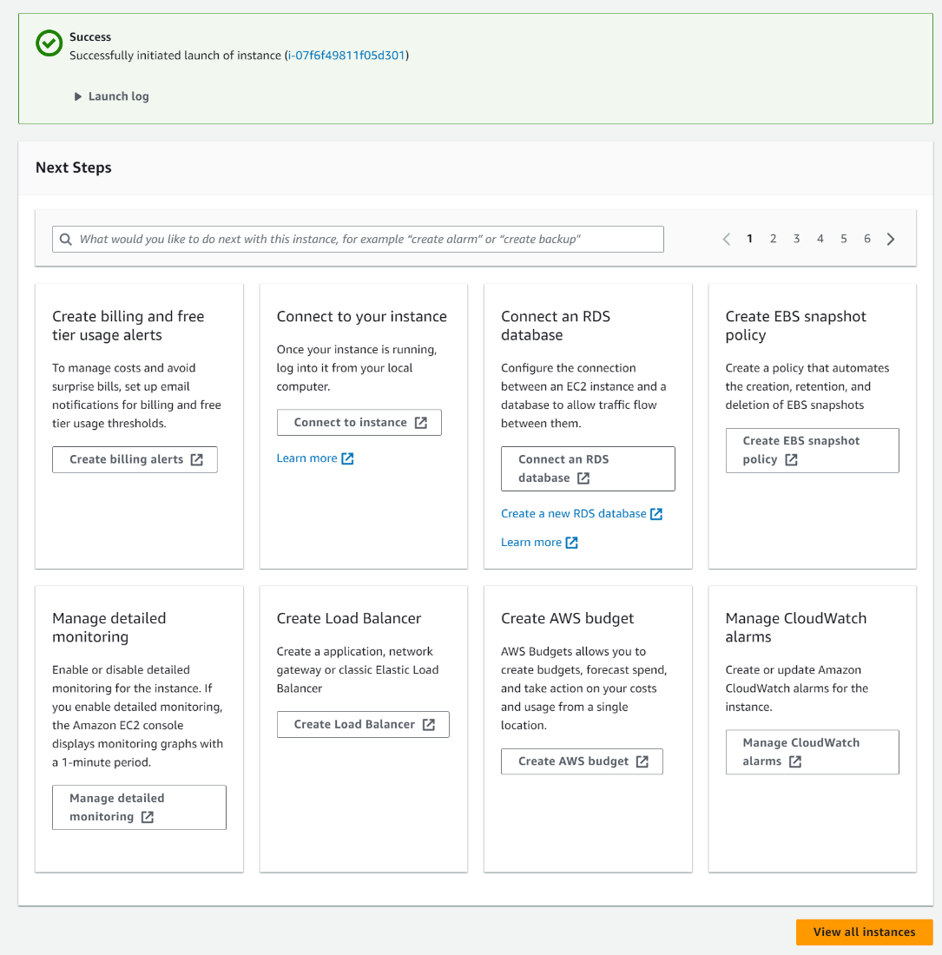

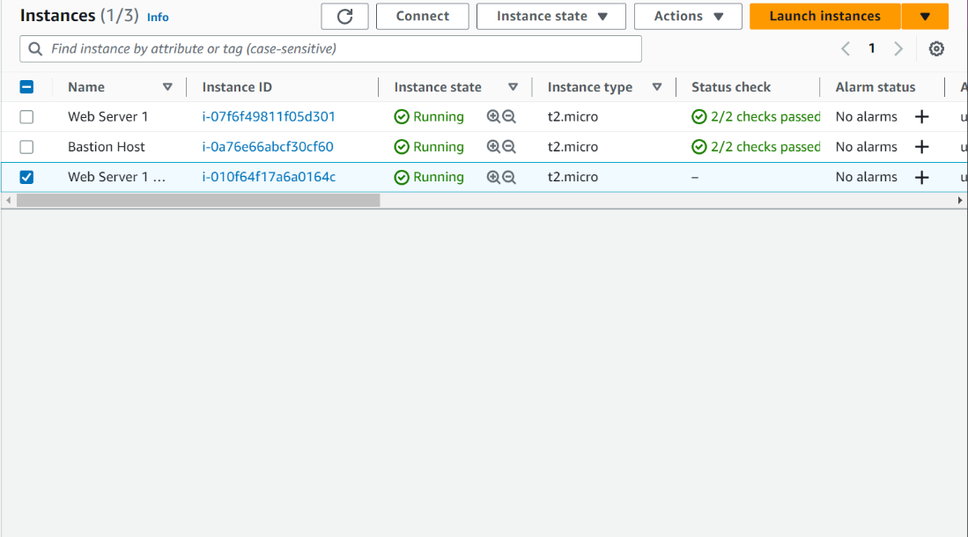

Lab 3

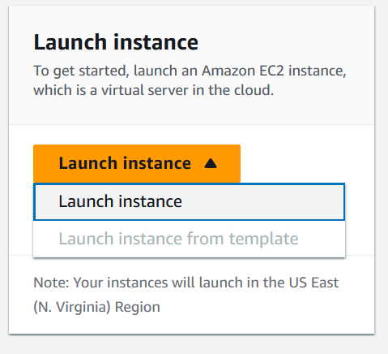

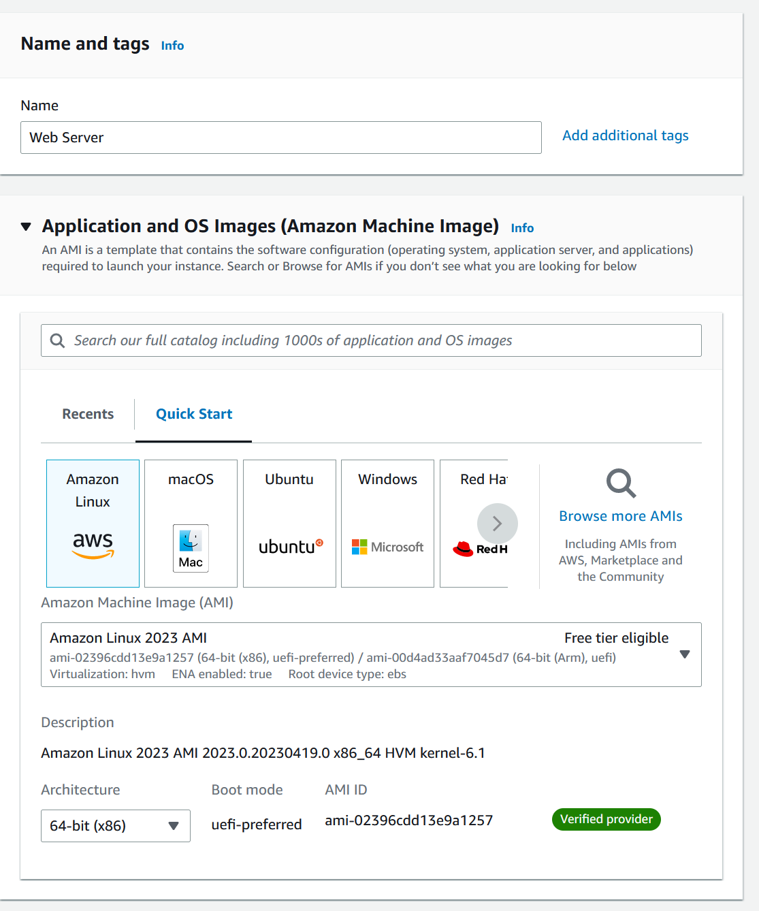

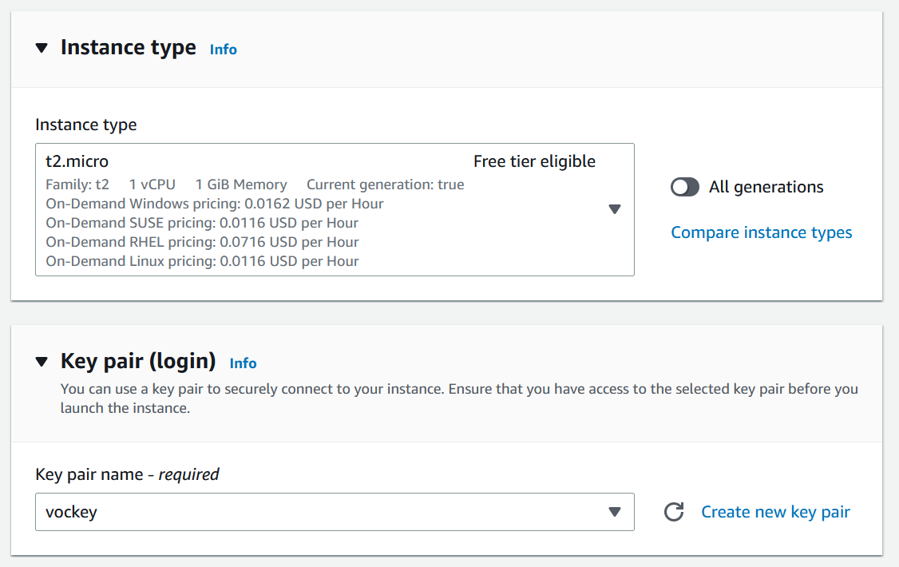

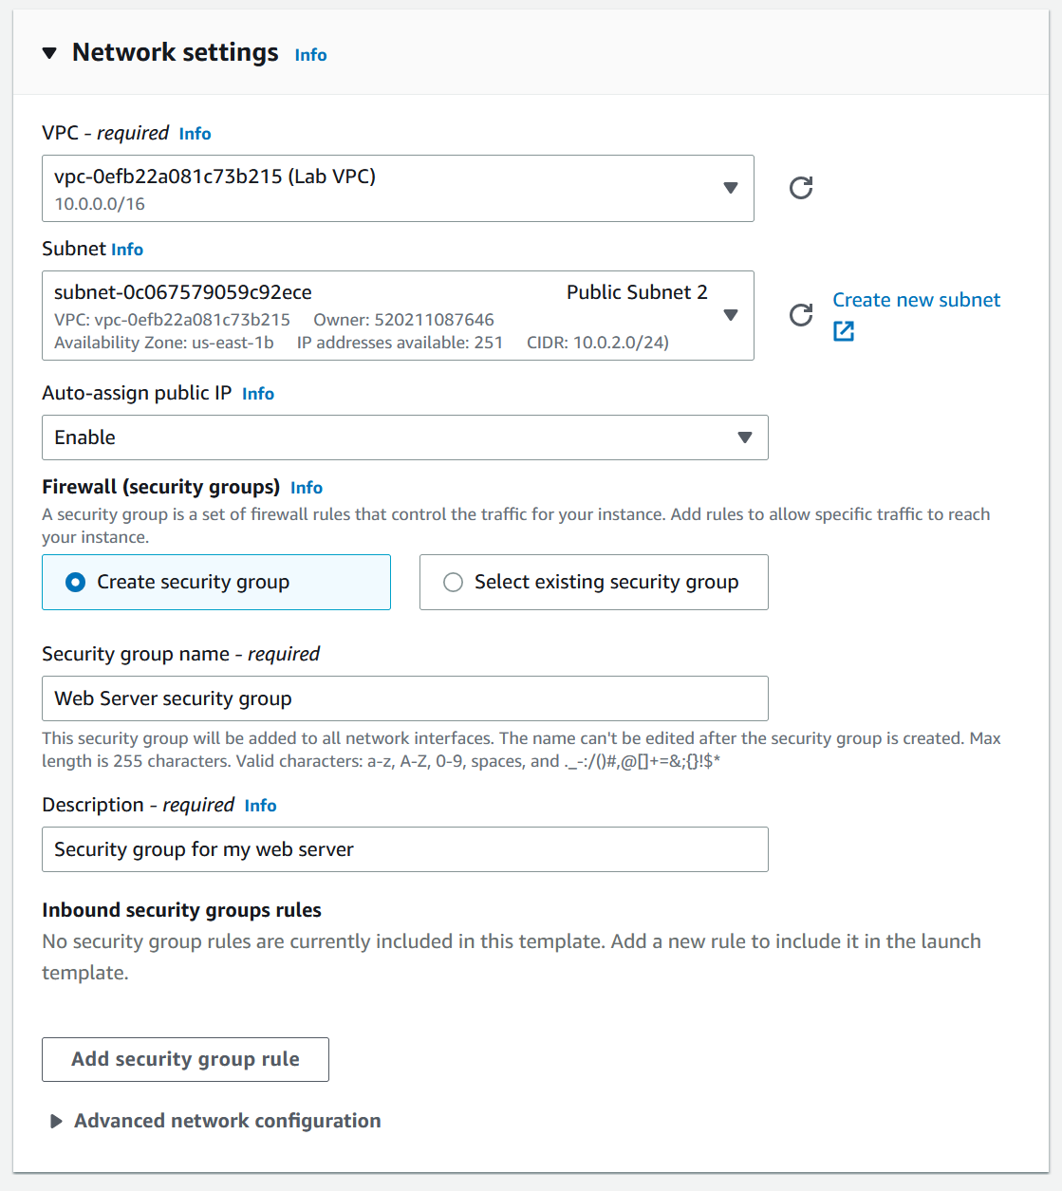

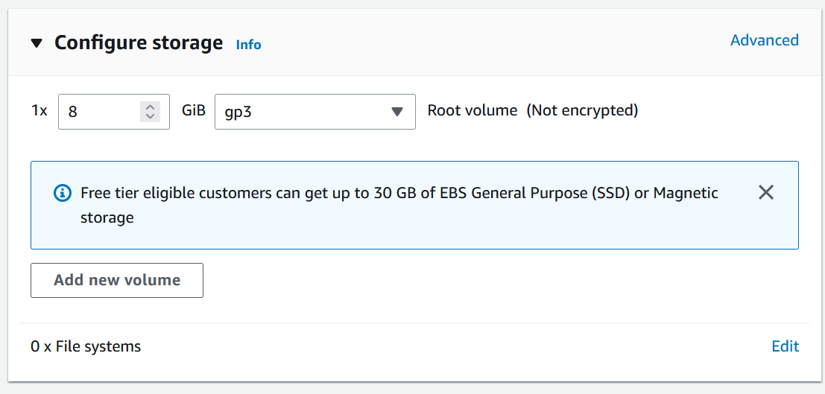

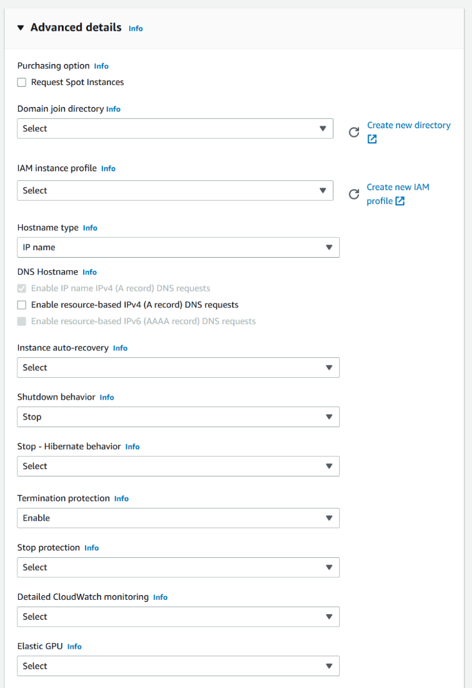

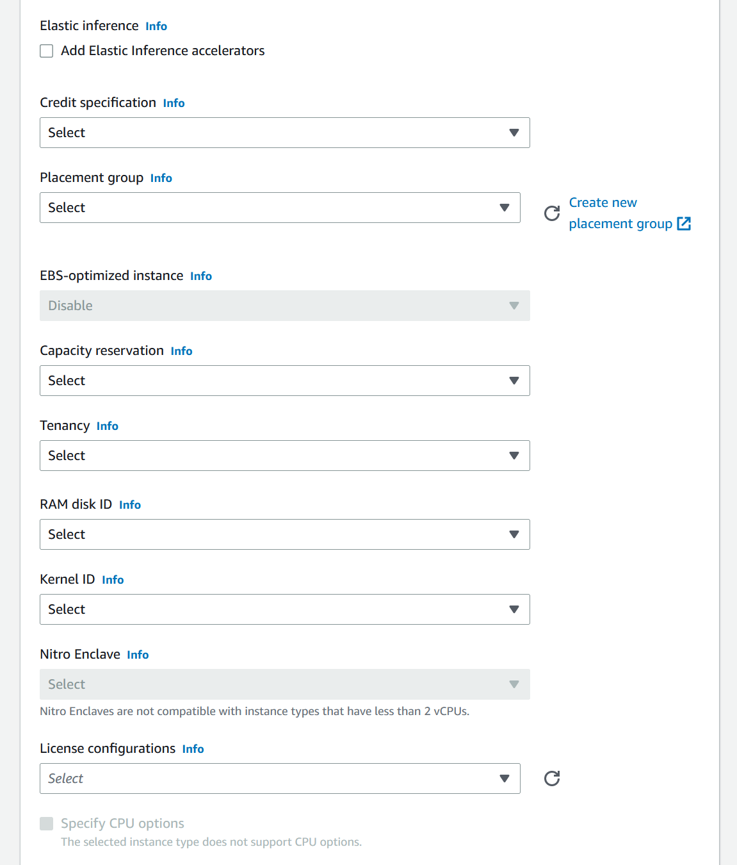

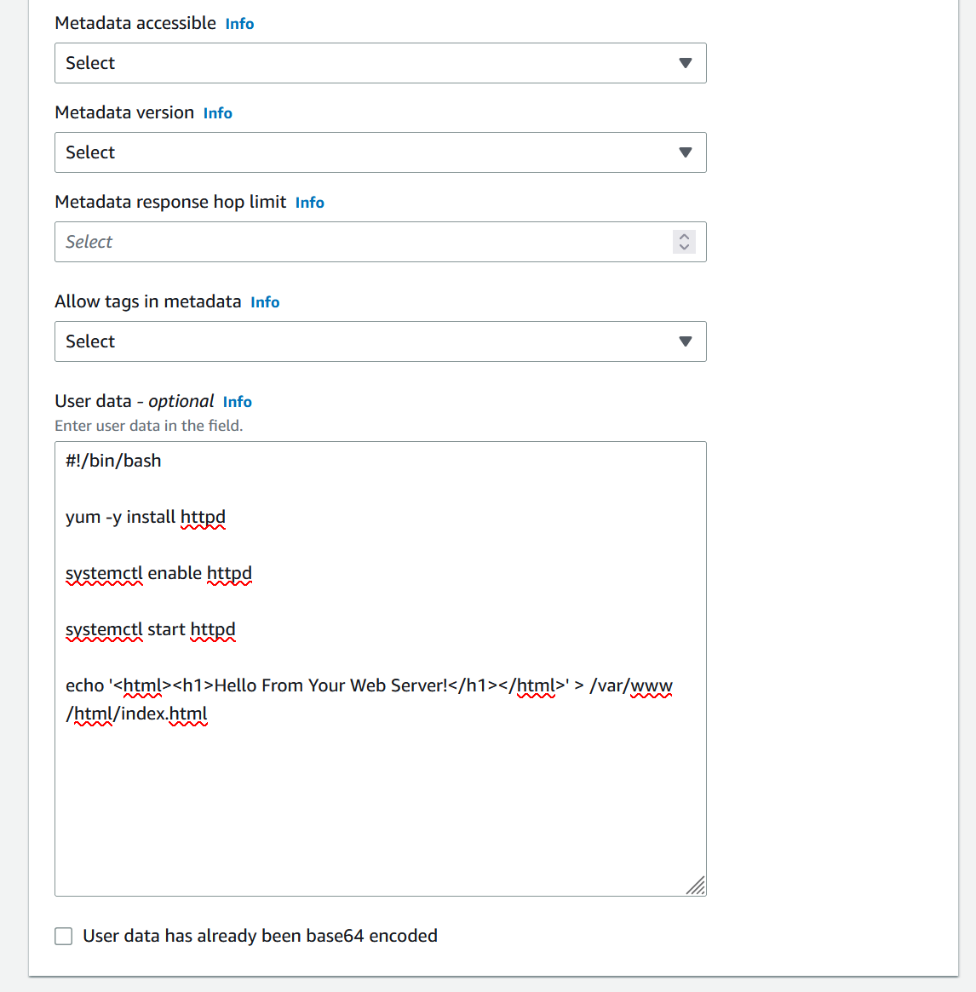

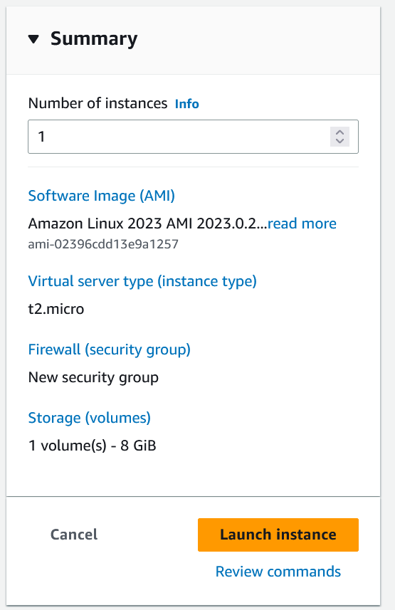

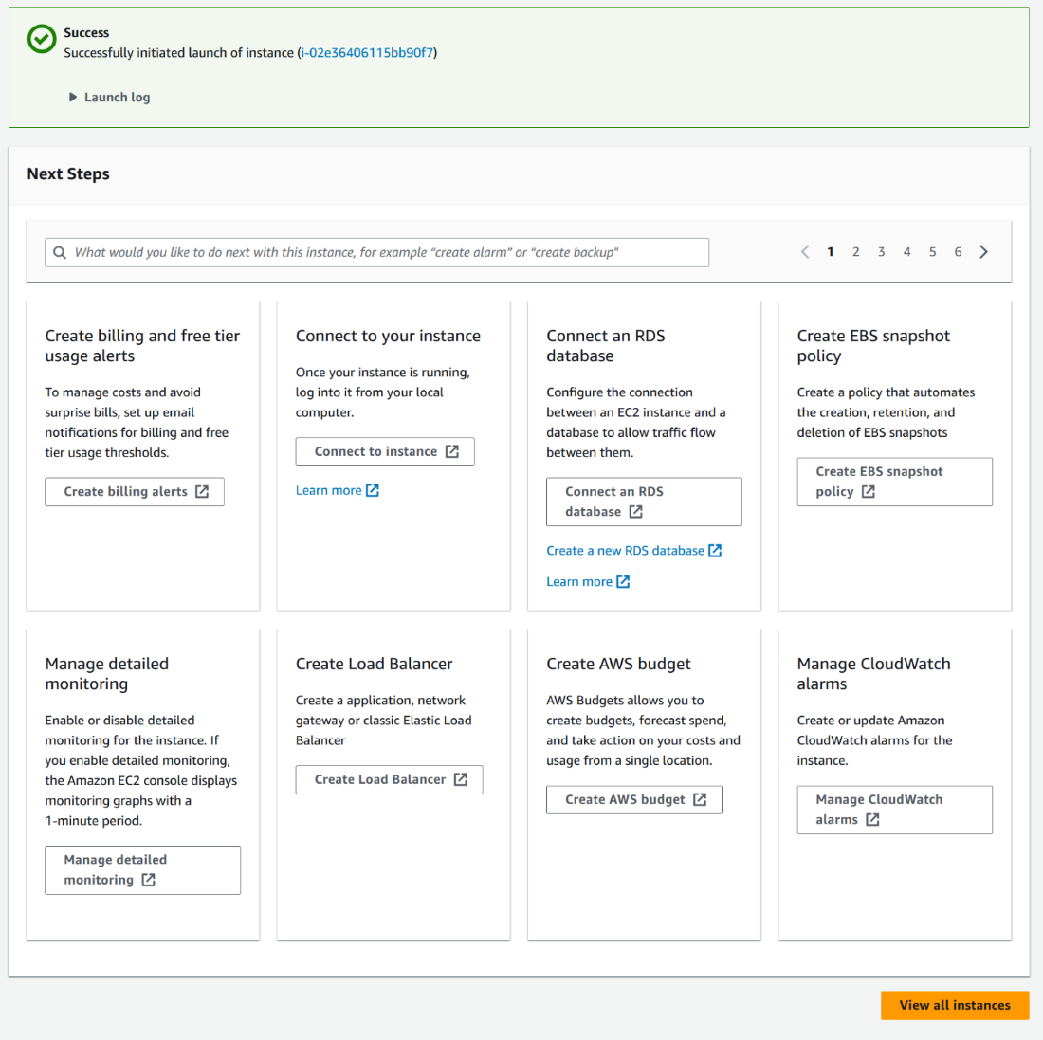





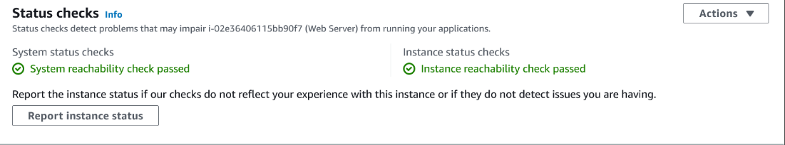

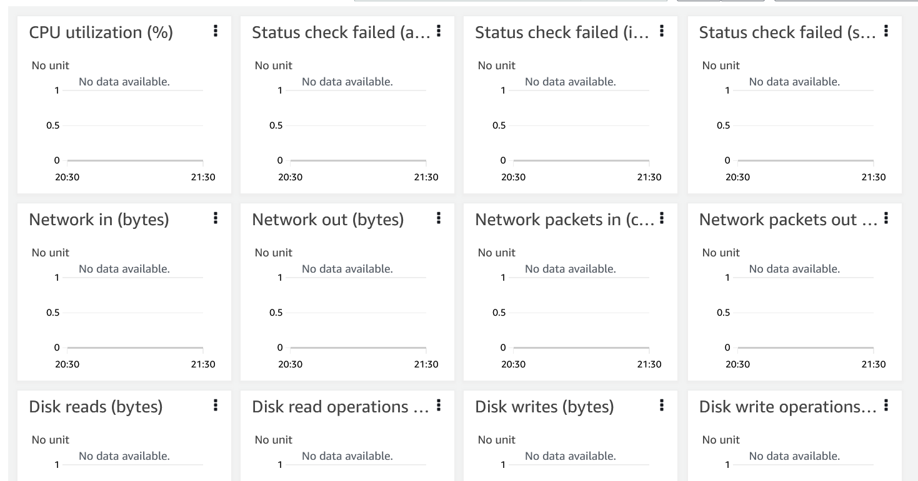

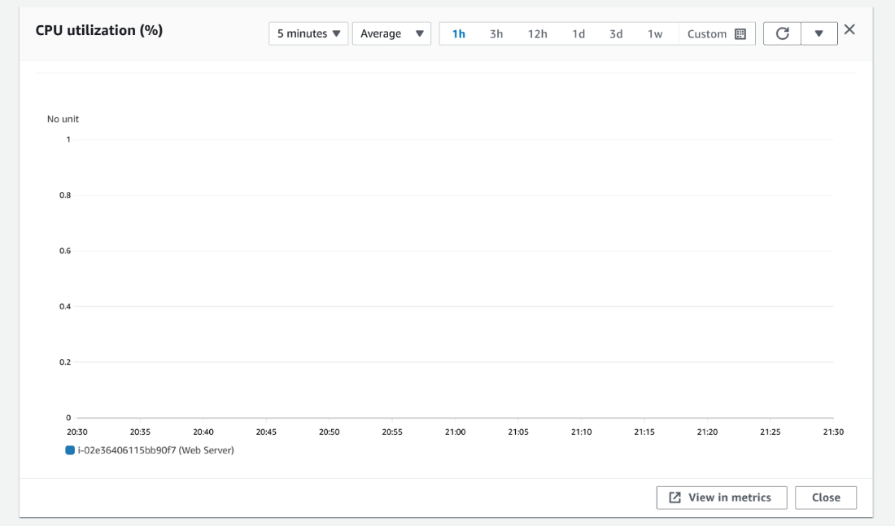

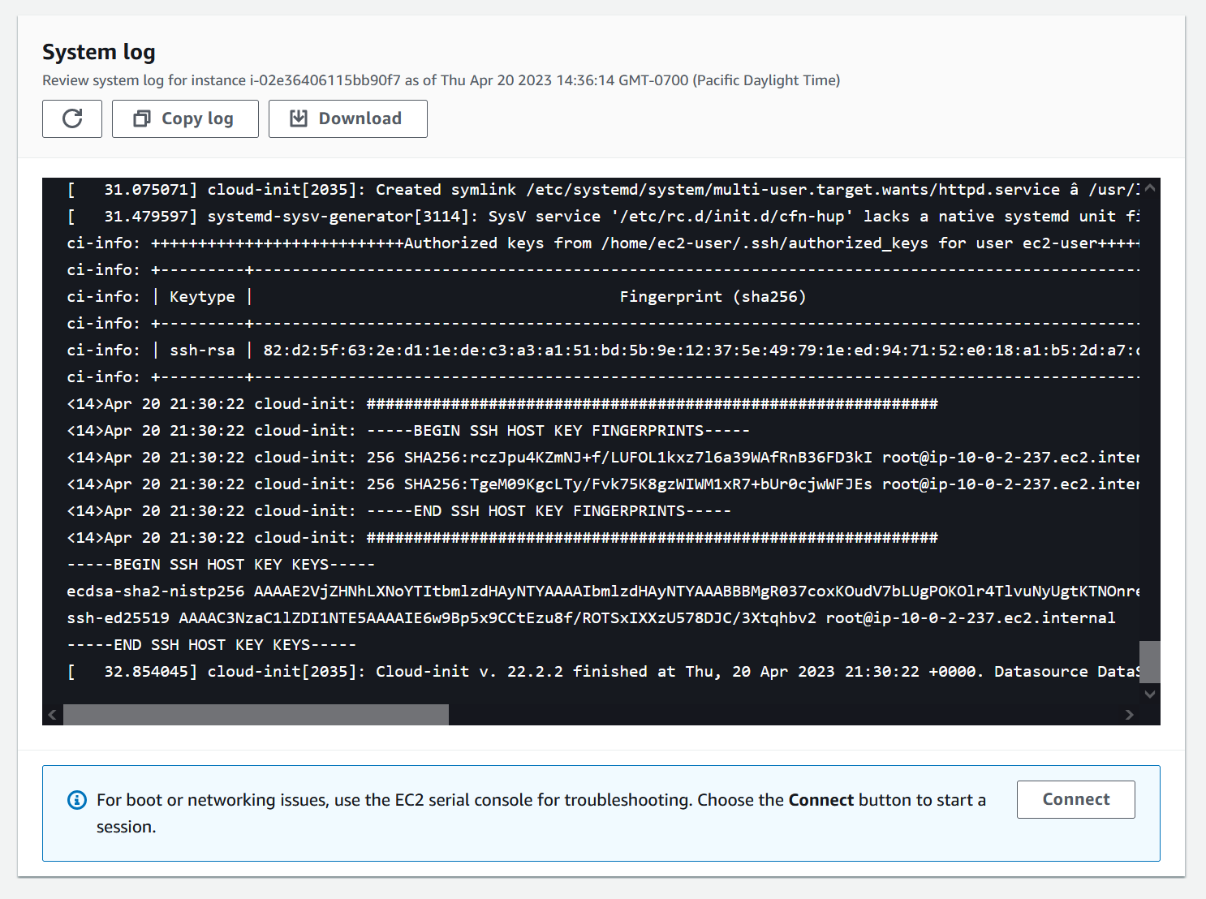

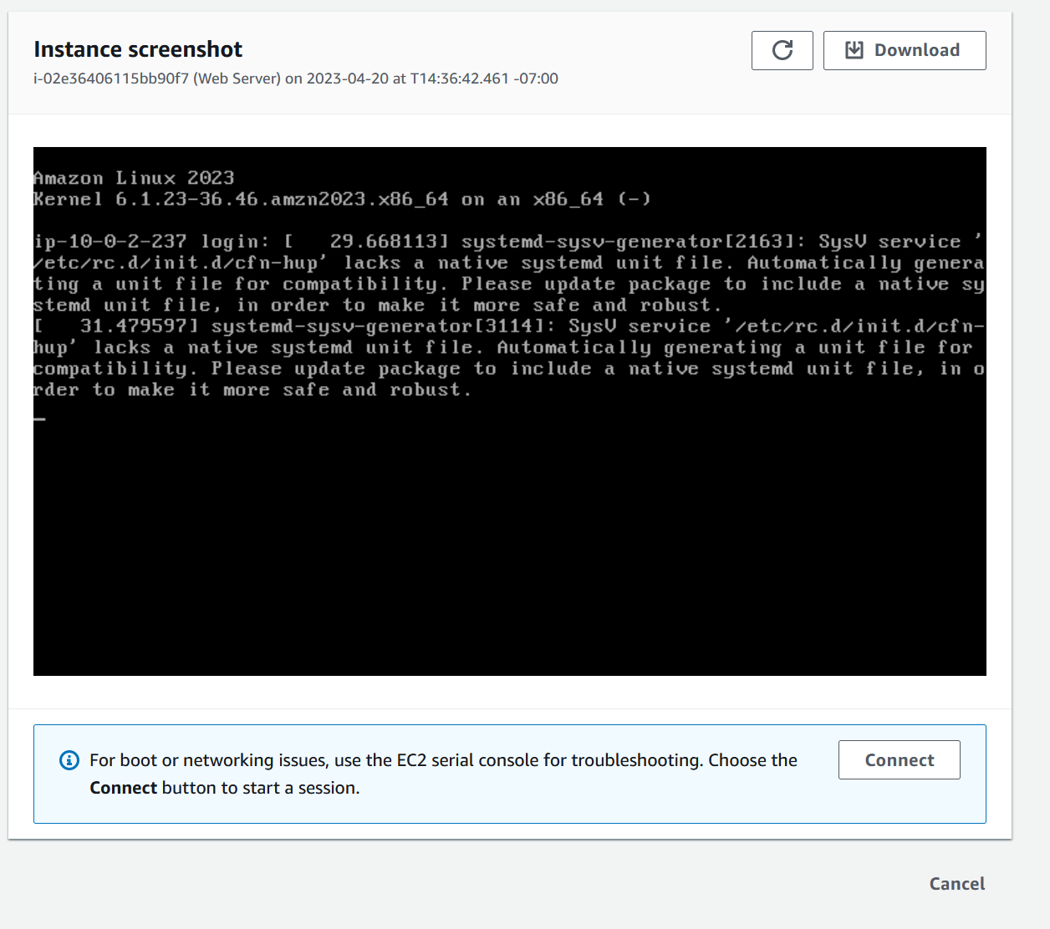

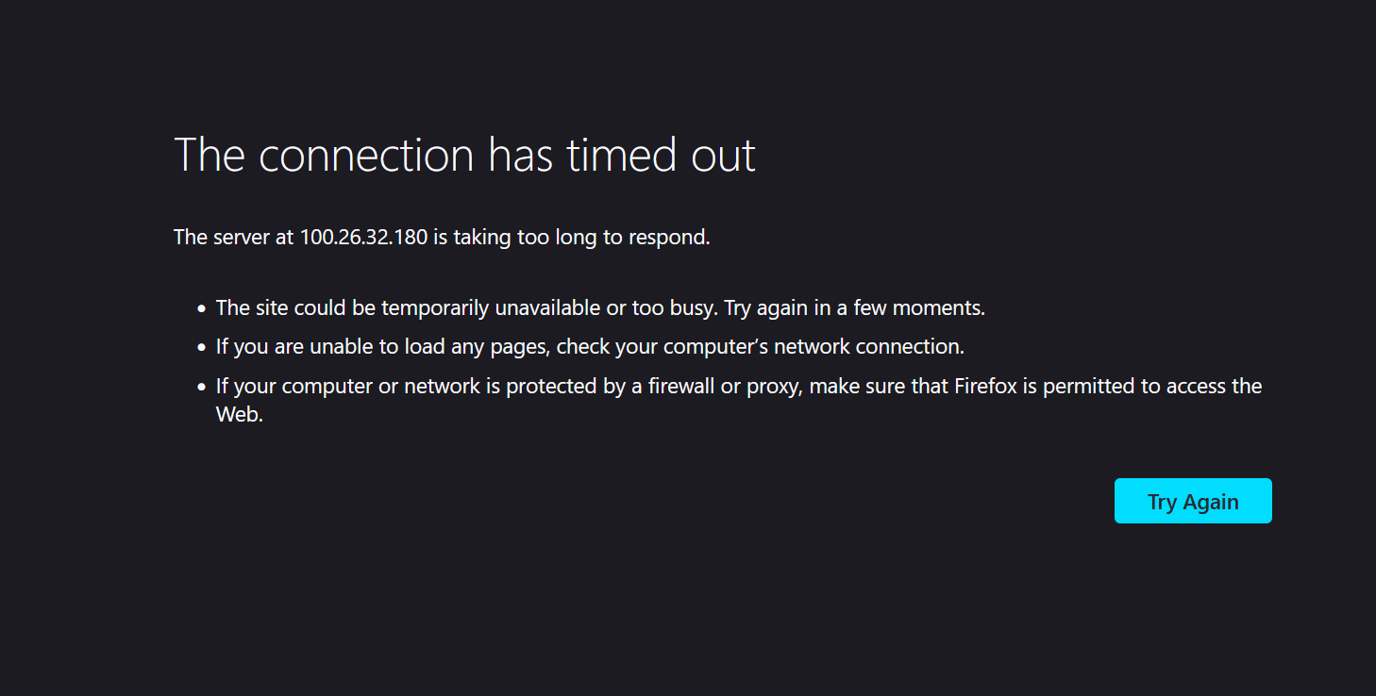

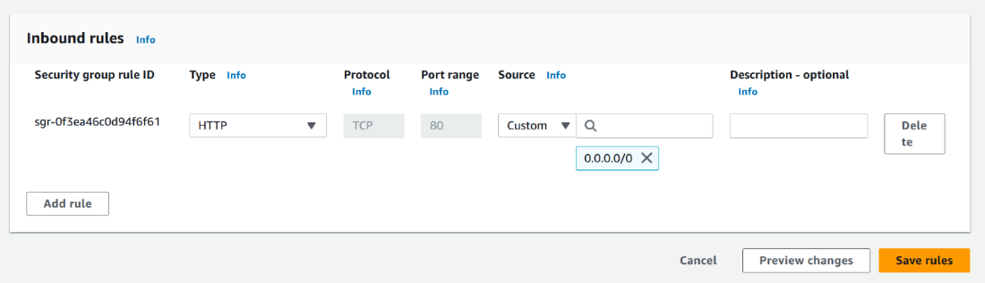

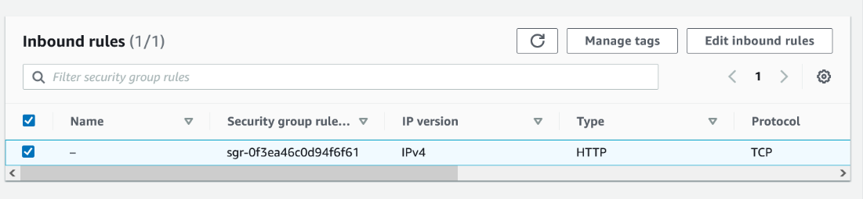

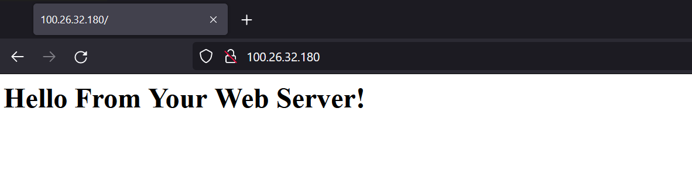





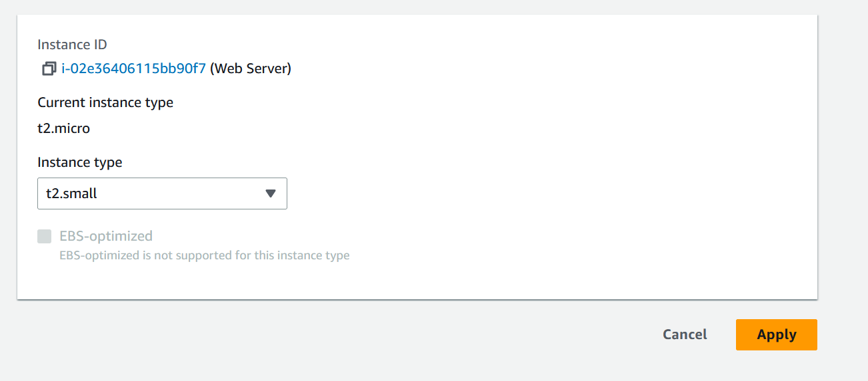



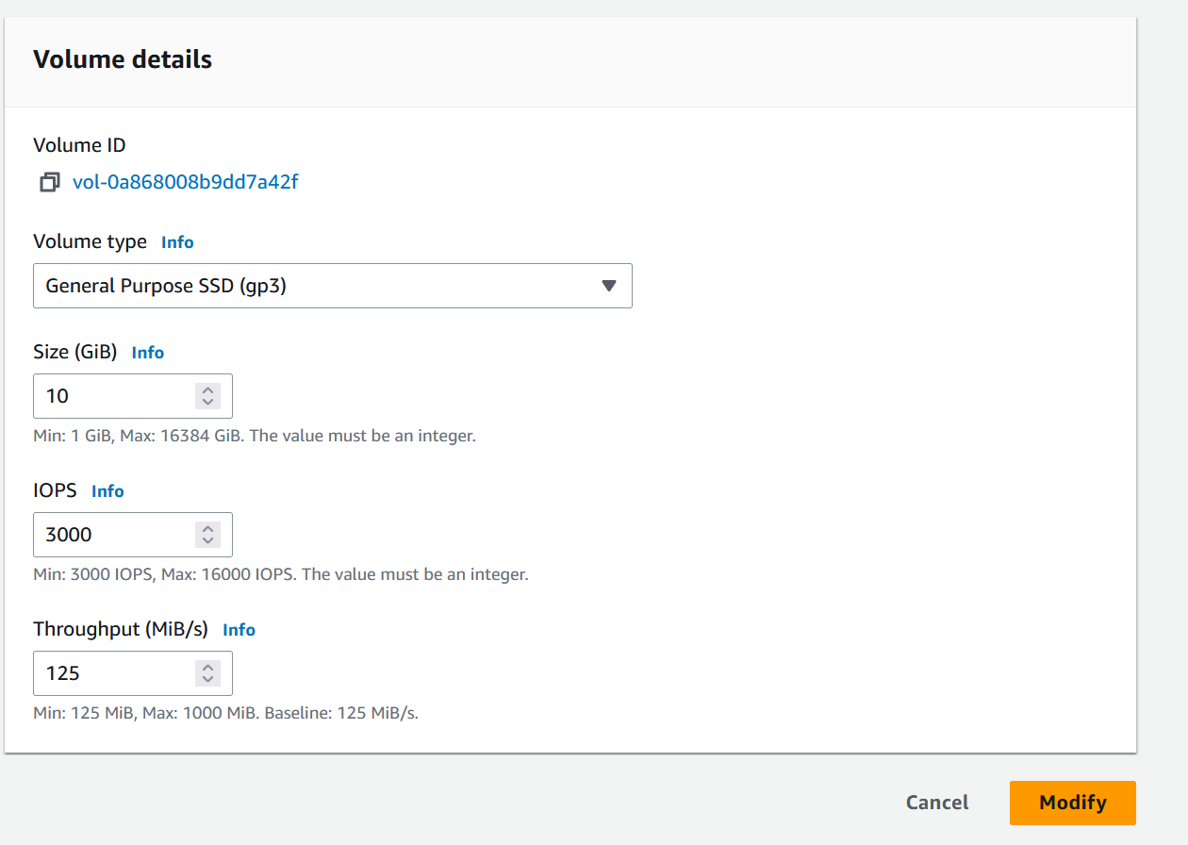

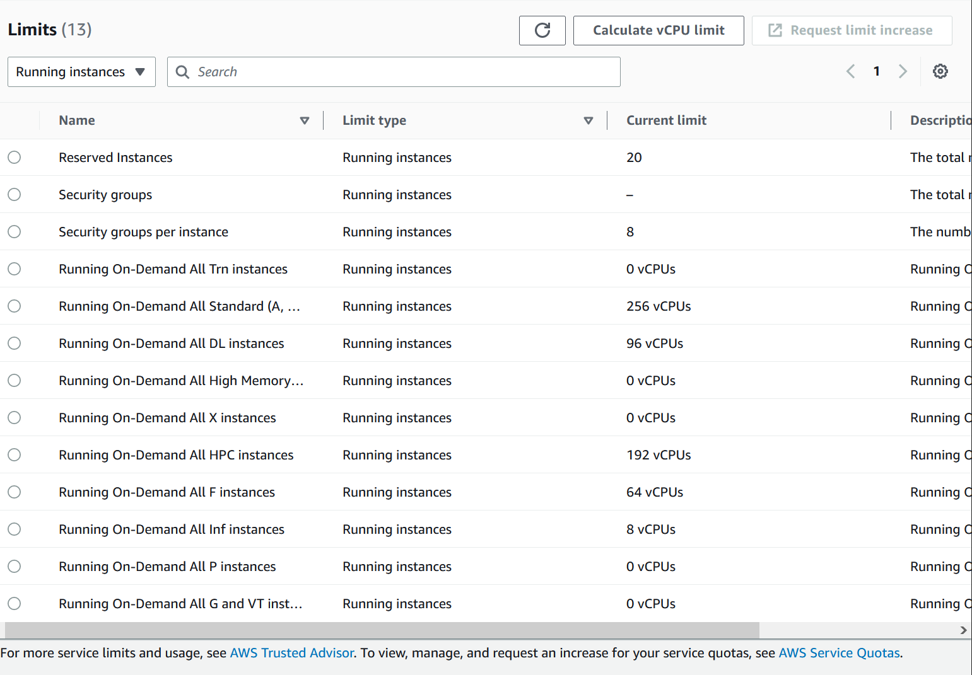

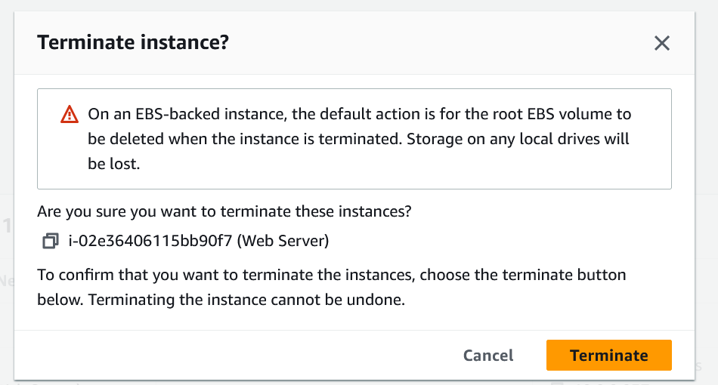



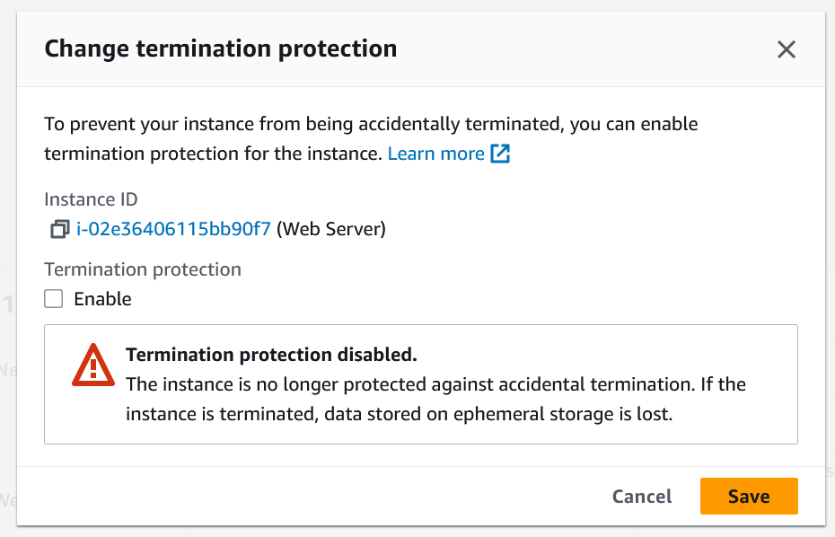

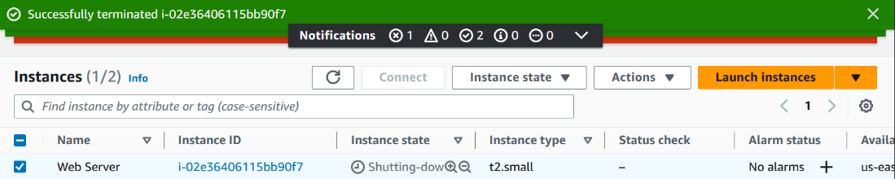

Because the labs told me exactly what to do, I didn't have many problems. One of them was in the second lab when I had to create a VPC called “lab-vpc.” I ended up ignoring one of the major steps: using the proper subnets. I had to change the default subnets of 10.0.0.0/20 and 10.0.4.0/20 to 10.0.0.0/**24** and 10.0.**1**.0/**24**. I forgot the change the subnets and left them as the default, so when it was time to create more subnets (10.0.2.0/24, 10.0.3.0/24), it complained that I already had those taken (from the 10.0.0.0/20, which goes from 10.0.0.0 to 10.0.15.255). I tried deleting the VPC, which failed. I tried to restart the lab and hoped that the VPC would magically go away, which also failed. In the end, I gave up and renamed the VPC from “lab-vpc” to some gibberish, then created a new VPC with the proper subnets. Overall, that whole fiasco took 30-45 minutes to solve, which wasn’t exactly fun to deal with, especially considering that the whole lab was meant to take 30-35 minutes. A bigger problem I had was that I didn't take any screenshots the first time I did the labs through. As a result, I had to redo the labs and complete them again to take the screenshots that I currently have in the lab.

In conclusion, I learned about AWS, how it works, and its advantages and disadvantages compared to traditional server rooms. I learned how to set up parts of AWS and get different parts to interact with one another. I did run into some issues, mostly that one VPC subnetting error. Overall, I learned a lot about how to set up all the devices and how they work together, which was fun to complete.